Institutional Ethics Committee for Human Research
Application for Ethical Review of Research Protocol

To Date:

The Member Secretary
Institutional Ethics Committee
Institute of Tran-disciplinary Health Sciences and Technology
Bengaluru

Dear Sir

Please find the study plan of my doctoral research. According to ICMR guidelines ‘National ethical Guidelines for Biomedical and Health Research involving Human Participants 2017’, the proposed study can be classified under ‘exempted review’ or ‘expedited review’ (Table 4.2, page 36 of the guidelines). However, as per TDU norms, I am submitting the plan of the study.

Full name of Principal Investigator:
Designation:
Complete Postal Address:
Tel. No: Office and Fax. No.
E-mail:

Site of study:
Title of Project:
Sponsor Name and address:

Sl. No. | Name | Signature
Principal Investigator
Co-Investigator
Co-Investigator
Type of study: Local / National / International
Type of Trial: Multi center / Single center

Name & Signature of Principal Investigator Date:

{Application must be submitted along with the study protocol, consent form (English and local language), Approval letters (if any, other scientific committee or ethics committee) and other essential documents for the review}.
COVER PAGE

Study Title:
Observational analysis of ayurvedic principles, ayurvedic hospital data, and patient outcomes

Study Plan for Doctoral Research

PROTOCOL NUMBER: To be filled by IEC office (any amendments should bear the amendment number)

PROTOCOL VERSION & DATE:
V1.0 & 21st Dec 2018

GENERAL INFORMATION

Name and address of the sponsor of the study
Dr. Girish Tillu
Dr. Ashwini Mathur
Vinay Mahajan

Name and address of the person authorized to sign the protocol and amendments

Name and address of guides

Name, title, address and telephone number(s) of the medical expert for the study

Name and title of the investigator(s) and sub-investigators responsible for the study with address and phone number(s)

Name and addresses of the clinical laboratories and/or other institutions involved in the study

IAIM Hospital

Table of Contents

1 Background 1
1.1 Investigational Agent 1
1.2 Preclinical Data 1
1.3 Risk/Benefits 1
1.4 Dose Rationale 1
1.5 Trial Conduct 1
1.6 Population 1
1.7 Literature 1
2 Trial Objectives 1
3 Trial Design 2
3.1 Primary Study Endpoints/Secondary Endpoints 2
3.2 Study Design/Type 2
3.3 Randomization 2
3.4 Maintenance 2
3.5 Trial Treatment 2
3.6 Duration 2
3.7 Discontinuation 2
3.8 Product Accountability 2
3.9 Data Identification 3
4 Selection and Withdrawal of Subjects 3
4.1 Inclusion Criteria 3
4.2 Exclusion Criteria 3
4.3 Subject Withdrawal 3
4.4 Treatment of Subjects 3
4.5 Medication 3
4.6 Monitoring for subject compliance 3
5 Assessment of Efficacy 4
5.1 Efficacy Parameters 4
5.2 Method and Timing 4
6 Assessment of Safety 4
6.1 Safety Parameters 4
6.2 Method and Timing 4
6.3 Adverse Event Reporting 4
6.4 Definitions 4
6.5 Adverse Event Follow-up 4
7 Statistical Plan 5
7.1 Statistical Methods 5
7.2 Subject Population(s) for Analysis 5
7.3 Significance 5
7.4 Termination Criteria 5
7.5 Accountability Procedure 5
7.6 Deviation Reporting 5
8 Direct Access to Source Data/Documentation 5
9 Quality Control and Quality Assurance 5
10 Ethical Considerations 6
11 Data Handling and Record Keeping 6
12 Finance and Insurance 6
13 Publication Plan 6
14 Supplements 6

List of Abbreviations

CFR Code of Federal Regulations

ICH International Conference on Harmonisation

CRF Case Report Form

FDA Food and Drug Administration

GCP Good Clinical Practice

IRB Institutional Review Board

1 Background

Real world data is the information relating to patient health status and/or the delivery of health care routinely collected from a variety of sources. This data holds potential to allow us to better design and conduct clinical trials and studies in the health care setting ; to answer questions previously thought infeasible. In addition, with the development of sophisticated, new analytical capabilities, we are able to analyze these data and apply the results much better to support standardized medical practice/methods, medical product development and approval.

Ayurveda has been practiced over many centuries in India. It will be safe to assume that the conceptual developments in ayurvedic knowledge base have taken place through every day observations and basic laws of nature. These fundamentals have been adjusted to the relevant times as per the passage of time, which is quite evident from vast literary history of Ayurveda which covers subjects like pharmacology, principle of diagnosis and treatment for all branches of medicine and surgery, philosophical framework and logic, pharmacy and numerous pharmacopeias. Traditional texts enumerate more than described for each disease condition (1).
Generating credible evidence for such a large pool only through modern experimental means such as trials is very challenging. Current hierarchical evidence model is being challenged by methodologists and the circular model comprising observational research methods are proposed for CAM research (2). Ayurveda like any other system of medicine, is practiced more in clinics than in clinical research setting, where there are no artificial restrictions on usage of medicines, duration of treatment or type of patients to treat, which is next to impossible in a protocol driven clinical trial setting. To plug the gap of missing empirical evidence, systematic analysis of observational clinical data is required. (3, 4) This project is focused on I-AIM clinical data for study of efficacy and safety trends.In our study of modern regulatory framework, we recognized similarity between concepts written by Charaka and ICH guidelines. This will form the philosophical basis for the research question.

Objective of the study: To explore clinical documentation and HMIS system in I-AIM hospital setting, to study data on disease classification, treatment protocols and outcomes. The focus of the exploratory analysis is clinical and patient reported outcomes in musculoskeletal and metabolic diseases.

Investigational Agent – Not Applicable
The study is based on the already treated patients at IAIM hospital over the years. All the relevant prescribed treatments available in the database will be utilized for the analysis purpose.

Preclinical Data – Not applicable
The study will be carried out on the existing patient data.

Risk/Benefits
Benefits: the existing patient data will be used retrospectively. The planned study will provide the following insights:
- What kind of data has been collected so far for each patient visit?
- What part of data is related to the every day to day operations
- What part of the data is related to the patient background characteristics, disease conditions, prescribed medicines?
- What are the strengths of the collected data and what are the areas of improvement going forward.
- What kinds of diseases are getting treated more frequently?
- What kinds of treatments are prescribed for what kinds of diseases?
This analysis would add to the evidence base of ayurvedic treatment principles.

Risks:
- The source database for data collection is not designed with the data analysis point of view hence extracting data in a desirable format is a challenge
- The existing database contains sensitive information related to individual patients. All the efforts will be made to protect sensitive information like
  - Name of patient,
  - Full address,
  - Phone numbers,
  - Socio economic status, etc.
This information will not be extracted from source data in order to maintain confidentiality and the patient cannot be traced back and contacted.

Dose Rationale – Not applicable

Trial Conduct – Not applicable

Population
Source data for patients having reported at least one disease in the following area will be used:
- Metabolic diseases,
- Rheumatic and Musculoskeletal disease, and
- Neuroscience

Literature
Hospital database, Ayurvedic reference material, Statistical methodological reference material, R software reference material, Tableau software reference material, SQL software reference material, US FDA website, EMA website, References for Real World Evidence.

Trial Objectives
Real World Evidence methods, epidemiological research methods like quantitative, qualitative and mixed methods research would be employed to explore the available data. In qualitative health research, observational methods provide direct access to what people do, as well as to what they say and think. These generate an emerging understanding about research questions with two main objectives:
- Preliminary analysis leads to the identification of issues where data need to be further enriched;
- It informs the sampling process, in the sense that researchers are aware of the point in the data collection in which no new categories/themes emerge – data saturation -, signaling that data collection is complete.

Studies of causation, prognosis, and clinical prediction will be carried out according to the quality of preceding evidence, using the optimal study design.

This proposed analysis, due to scale and size of the data, with no artificial limitations of inclusion and exclusion criteria should provide real world evidence view or the epidemiological view for the stated period (from the beginning of hospital in 2011 to October 2017). This will provide additional understanding about ayurvedic data that may be inaccessible using quantitative methods. Basic understanding of the demographic, background history, visit pattern, treatments prescribed at such a large scale should help in building empirical evidence.

Trial Design
The scientific integrity of the trial and the credibility of the data from the trial depend substantially on the trial design.

The database captures complete picture of patient experience in day to day clinical practice. It captures modern medical parameters obtained through various blood tests, scans, ECGs, etc. as well as it captures Ayurvedic parameters in carefully designed Case Report Forms. The source data is secured in a controlled environment with SQL database at the back end. This data is accessed using SQL queries and then using R programming language for necessary calculations. Summarization and tabulation are carried out using R libraries; visuals are built using tableau software for a very easy to use end user experience. The following steps were followed to convert an individual observation to a meaningful table or a visual (References in supplementary material, Fig 1, 2, 3, and 4). The source data is captured in multiple data tables or views, and these need to be combined or aggregated into meaningful data tables for further processing. To get to a consolidated Data version of 25 variables, 15 different data tables had to be processed.

R is a programming language and free software environment for statistical computing and graphics that is supported by the R Foundation for Statistical Computing. The R language is widely used among statisticians and data miners for developing statistical software and data analysis.

Tableau (French for 'little table' literally, also used to mean 'picture'; pl. tableauxor, rarely, tableaus) is a software providing visual query language interface to convert large amounts of data into beautiful interactive graphical displays.

Both these are freeware softwares or open source, hence there is no additional financial burden on researchers to procure the best in class analytical capabilities.

Fig 1:
Use R program to generate tabular or graphical analysis
Use R program to create analysis data tables
Use source tables from the SQLserver
Use SQL queries to combine necessary tables
Use Tableau to generate interactive visual analysis

- Login on the SQL server using the credentials
- Use the IAIM schema and access the following tables to generate base table with Demographics information, Patient Visit information and prescribed treatments
  - STATE_MASTER
  - COUNTRY_MASTER
  - CITY
  - STATE
  - PATIENT_DETAILS
  - PATIENT_REGISTRATION
  - MRD_DIAGNOSIS
  - PATIENT_PRESCRIPTION
  - PATIENT_MEDICINE_PRESCRIPTIONS
  - IP_PRESCRIPTION
  - SERVICES_PRESCRIBED
  - SERVICES
  - MEDICINE_SALES_VIEW
- There are many CRF pages built to collect relevant Ayurvedic data, measurement data, Hospital visit data, food / exercise advice, etc. This data is present in the following tables:
  - PATIENT_SECTION_DETAILS
  - PATIENT_SECTION_VALUES
  - SECTION_MASTER
  - SECTION_FIELD_OPTIONS
  - SECTION_FIELD_DESC
  - PATIENT_CONSULTATION_FIELD_VALUES
- The datasets created in steps 2 and 3 are further processed using R programming language and the analysis ready datasets are created

Fig 2: SQL code to extract data from the SQL database
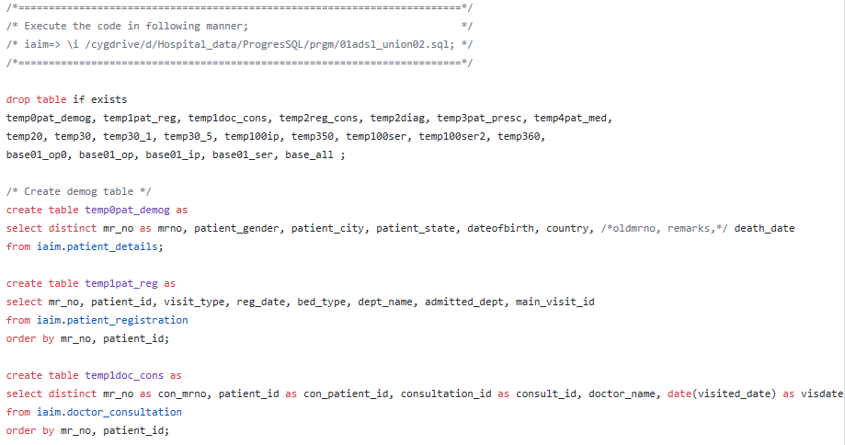
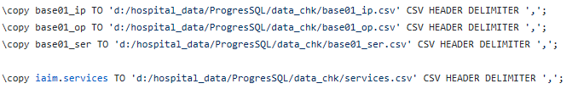

Fig 3: R code, use the input files created using SQL queries
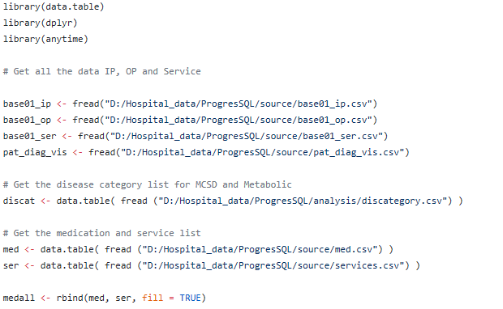
...
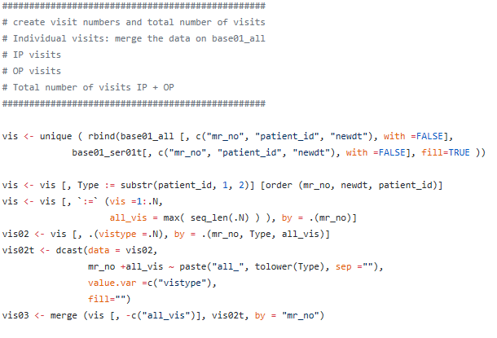

Fig 4: One of the datasets with key variables
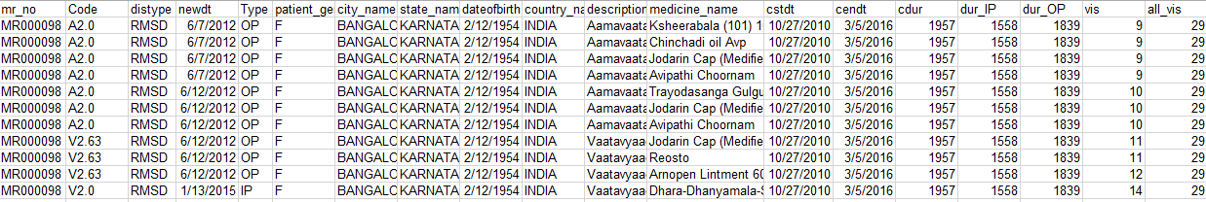

The snapshot shows following variables:
- patient ID,
- Disease code,
- Disease type,
- Date of visit,
- visit type (IP, OP),
- gender,
- city,
- state,
- date of birth,
- Country,
- Description of disease,
- Medicine name,
- Start date,
- End date,
- Total duration,
- In Patient duration,
- Outpatient duration,
- Visit number,
- Total number of visits, etc.

Primary Study Endpoints/Secondary Endpoints
Endpoints used in daily ayurvedic clinical practice.

Study Design/Type
Real World evidence approach employed to the existing data. Ayurvedic hospital in TDU is operational since year 2011 and hosts one of the largest electronic databases of Ayurvedic medical practice. The hospital database contains clinical data for more than 51000 patients since 2011 to October 2017. The Ayurvedic disease classification dictionary (ACD) is used to code the diseases [Dictionary developed at the University, and CDAC, Pune]. There are approximately 170,000 visits recorded, covering more than 900 unique diseases, more than 3000 medicinal procedures*, in-patient as well as out-patient visits.

The existing patient level data will be utilized. This data will be referred to as “Source data”. Source data will be accessed from the existing database. Source data reported from day 1 of hospital till October 2017 will be used. This source data is further processed to add new variables for analysis purpose and new datasets called as “analysis data” are created

Randomization – Not applicable

Maintenance – Not applicable
This is a retrospective data analysis of ongoing medical practice data at the IAIM and hence no blinding of data or randomization was done. During the course of data analysis completely confidentiality of patient information which would lead to tracing the patient was maintained by not extracting the actual patient name, address and other details in the analysis dataset from the source data.

Trial Treatment – Not applicable
Ayurvedic treatment/ Regime for the following disease area are considered in the analysis:
- Metabolic diseases,
- Rheumatic and Musculoskeletal disease,
- Neuroscience,
- Cancer

Duration
Source data from 2011 to October 2017

Discontinuation – Not applicable
This being a retrospective study of data; discontinuation reasons were studied and reported as a part of summary of data.

Product Accountability – Not applicable

Data Identification
All the data available in the source database which will be analyzed. Sensitive information related to Patient identification will not be extracted for analysis from source data. Details on how much data will used and what will be excluded is explained in the analysis section below.

Selection and Withdrawal of Subjects

Inclusion Criteria
Patients having the following diseases reported at least once in the hospital database

list

, :

Neurological diseases,
Cancer

Exclusion Criteria
Patients who do not have any of the above reported diseases in the hospital database.

Subject Withdrawal – Not applicable

Treatment of Subjects – Not applicable

Medication – Not applicable

Monitoring for subject compliance – Not applicable

Assessment of Efficacy

Efficacy Parameters
Efficacy parameters used in daily clinical practice will be used for this purpose.

Method and Timing
Efficacy data collected as per vaidya’s advice at regular visits will be analyzed.

Assessment of Safety
Safety parameters used in daily clinical practice will be used for this purpose.

Safety Parameters
Safety data collected as per vaidya’s advice at regular visits will be analyzed.

Method and Timing
Safety data collected as per vaidya’s advice at regular visits will be analyzed.

Adverse Event Reporting – Not applicable

Definitions – Not applicable

Adverse Event Follow-up – Not applicable

Statistical Plan
Exploration of data will be carried out to understand various components of the data. This will involve the following aspects:
- Inspection of data collected over the years
- Understand and describe the data present in Case Report Forms,
- Understand and describe the operational part of the data
- Understand and describe the clinical part of the data

Statistical Methods
- Statistical methods to be employed:
  - Graphical methods to display a lot of data in a concise form, trellis graphics, heat maps, etc.
  - Pattern or trend analysis: to understand the underlying clusters within the data
  - Decision theory analysis: to understand how the treatment gets assigned and what calculations, algorithms go through a doctor’s mind
  - Multivariate analysis: to model the data and gain more insights
- Innovative and emerging tools and techniques from Omics / bioinformatics etc.

Subject Population(s) for Analysis
As explained in section 4.1. These sets of patients will be used for the analysis. Any patient having at least a single visit will be included in the analysis.

Significance – Not applicable
Exploratory analysis will be carried out, hence there is no significance testing done.

Termination Criteria – Not applicable

Accountability Procedure – Not applicable

Deviation Reporting – Not applicable

Direct Access to Source Data/Documentation

Hospital database will be accessed to extract the current data. The source data will not modified.

Quality Control and Quality Assurance
All the analysis methods will be documented stepwise. These will be reviewed by guides independently. Manual checks for data consistency will be done by having regular meetings for review of the data analysis. Cross comparison of a few cases with the Case Sheets will be carried out for data plausibility.

Ethical Considerations
The existing data will be used to understand the clinical insights.
- Sensitive information related to the treating doctors will not be extracted for analysis purpose.
- Sensitive information related to the patients will not be extracted for analysis purpose.
- Any data analysis with very few patients (e.g. less than 5) will not be undertaken to additionally protect potential un-anonymization of patients.

Data Handling and Record Keeping – Not applicable

Finance and Insurance – Not applicable

Publication Plan
The data contents, analysis and any publications made to the external world will be owned by TDU.

Supplements
Insert any other documentation for the trial.

Following documents must be submitted:
1. Application form (scanned copy/original can be submitted while applying for review; original must be submitted to receive approval letter)
2. Study protocol
3. Data collection tools
4. Consent form (English and local language)
5. CV of investigators
6. Any other relevant documents

Analysis description and details:

Understanding the hospital database
The hospital database has been created to capture patient level information as well as operational information. The data is collected in various Case Report forms and in various columns called as “variables”. Each Case Report form is systematically stored in a logical table. These tables and variables are named appropriately so that the end user will be able to utilize the data for further analysis. Please find the list of tables and names of the tables where the source data is captured and stored.

CRF number  (section_id) | CRF page name  (section_title) | Classification
1 | History of Present Illness | Ayurvedic data
2 | Review Of Systems
3 | Physical Examination
4 | Past / Family / Personal History/History of trauma/ injury | Ayurvedic data
5 | Nurse Assessment
6 | Gyn History
7 | OBG History
8 | Samprapti Ghatakas | Ayurvedic data
9 | Rogi Pareeksha | Ayurvedic data
10 | Session
11 | Roga Vinischaya
12 | Systemic Examination
13 | Investigations
14 | Complaint
15 | IP Case Proforma
16 | General Examination1
17 | Local Examination
18 | Nidana
19 | Dashavidha Pareeksha | Ayurvedic data
20 | Nutitional Assessment
21 | General Examination
22 | Breathing Practices
23 | Loosening Practices
24 | Postures | Ayurvedic data
25 | Kriyas
26 | Pranayamas | Ayurvedic data
27 | Mudras | Ayurvedic data
28 | Bandhas
29 | Relaxation Techniques
30 | Meditation Techniques | Ayurvedic data
31 | Netra Case Sheet
32 | Vitals
33 | Visual Acuity Test
34 | Glass Power Prescription
35 | Other Findings
36 | Nephrology Case sheet
37 | Personal History
38 | Vihara
39 | Wellness assesment of child
40 | GROWTH & DEVELOPMENT ASSESSMENT
41 | Dosha Assessment Questionnaire
42 | Diet Recommendations
43 | Operation Notes
44 | Conduction Notes
77 | IP - History of Present Illness | Ayurvedic data
78 | IP - Gyn History
79 | IP - Samprapti Ghatakas | Ayurvedic data
80 | IP - Nidan Panchak | Ayurvedic data
81 | IP – Session
82 | IP - Roga Vinischaya
83 | IP - Systemic Examination
84 | IP – Investigations
85 | IP – Complaint
86 | IP - Local Examination
87 | IP - Dashavidha Pareeksha
88 | IP - Nutitional Assessment
89 | IP - General Examination
90 | Visit Breathing Practices
91 | Visit Loosening Practices
92 | Visit Postures
93 | Visit Kriyas
94 | Visit Pranayamas
95 | Visit Mudras
96 | Visit Bandhas
97 | Visit Relaxation Techniques
98 | Visit Meditation Techniques
99 | Doctor Advice
100 | Oral Cavity | Ayurvedic data
101 | Ear
102 | Nose
103 | Complaints And Associated Complaints
104 | History of Previous Illness
105 | Medical History
106 | Investigation.
107 | Obstetrical History
108 | Food Habit
109 | Activity(Vihara)
110 | Physical.Examination.
111 | ASTA STHANA PARIKSHA | Ayurvedic data
112 | DASHA VIDHA PARIKSHA | Ayurvedic data
113 | Date
114 | Treatment Plan
115 | Final Diagnosis
116 | Physiotherapy Treatment Plan
117 | Physiotherapy Short term Goal
118 | Physiotherapy Long Term Goal
119 | Yoga Treatment Plan
120 | Physiotherapy Assessment
121 | Physiotherapy Outcome
122 | ROGA VINISCHAYA
123 | ROGA VINISCHAYA – IP
124 | CCHPI
125 | Health History: Do you have Or have you ever had any of the following?
126 | CLINICAL EXAMINATION

The rows in the table above marked in yellow color contain very little data (33 tables out of 66), so are not utilized for the analysis purpose. The tables and variables are classified into following sections to get an idea about what kind of data is collected:
- Ayurvedic data
- Background
- Disease
- Doctor's Notes
- Food / Exercise
- Hospital Visit
- Lab report
- Measurement
- Treatment / Procedure

This data was analyzed to understand data collection pattern for patients. If there is any non-missing data present in a particular variable or a column then a pseudo value “Yes” is assigned, if the data is missing then a pseudo “Blank or No” value is assigned for the purpose of analysis. Tableau display is presented below as an illustration.

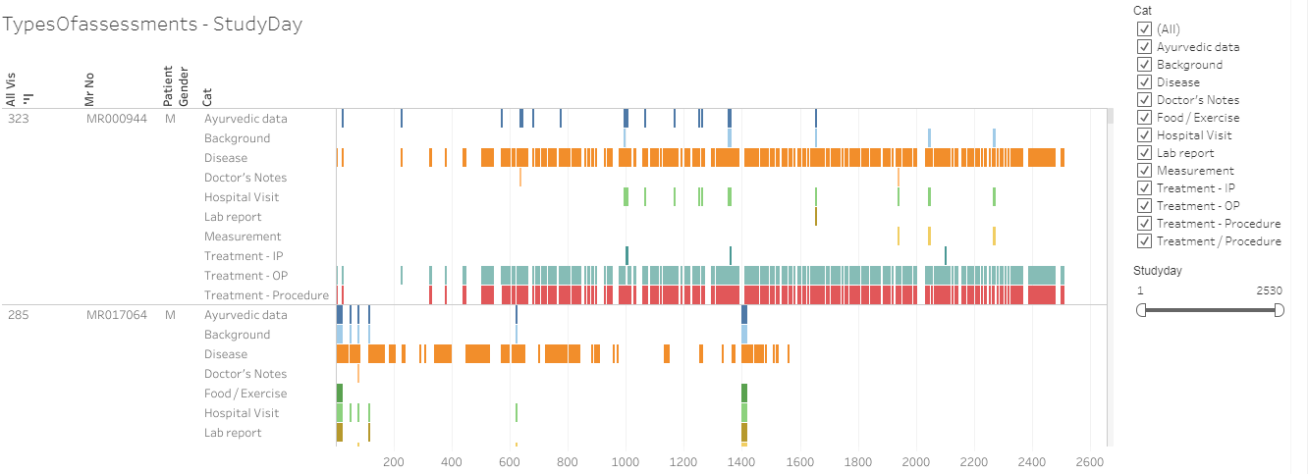

The analysis carried out shows that for majority of the patient and for majority of the visits, the disease data and medication (Treatment /Procedure) are entered and is not missing. Most of the other categories are not entered as consistently as they should have been. This lack of information should be addressed.*

References to the analysis files:
R program | 03_typesOfassessment.R
Datafile | 03_typesOfassessent.csv
Tableau vizname | 03_typesOfassessment
Tableau sheetname | TypesOfassessments – StudyDay

Understanding variables from various CRF pages
The following analysis provides information about the quality of the data captured, distinct number of patients present in individual table as well as unique values present for various variables.
- 50% of CRF pages are with very little number of patients and patient data, hence not used for analysis
- There are many variables where captured data is in a “free text” format. Although, this provides the doctors flexibility during data entry and the complete information gets captured but results in
- challenges in analysis and lower data accuracy viz.
  - Same data value could be represented in different cases
  - minor spelling mistakes,
  - human errors in data handling, etc.

E.g. Let us take a look at the following row in the table below:
sec001_var008_Diabetes | 1064 | 4124 |  |  | Background

- sec001_var008_Diabetes: presents CRF page 1 “History of Present Illness” and variable number 8 “Diabetes”.
- This variable has 1064 unique values entered by different doctors for different patients.
- There is some entered data for 4124 distinct patients and
- This variable is categorized as variable capturing data for category “Background”.

Another example:
sec001_var018_Associated Complaint with Onset & Duration | 5102 | 4549 |  |  | Disease

- sec001_var018_Associated Complaint with Onset & Duration: presents CRF page 1 “History of Present Illness” and variable number 8 “Associated Complaint with Onset & Duration”.
- This variable has 5102 different values entered by different doctors for different patients.
- There is some entered data for 4549 distinct patients and
- This variable is categorized as variable capturing data for category “Disease”.

The above data supports the following areas of improvements:
- Standardization of CRF pages for better data capture – there are some standards already available in healthcare industry, they could be implemented at the hospital.
  - CDISC standards
  - ISO standards
- Implementation of the standard dictionaries to capture data uniformly and make analysis ready, some of these could be directly implemented; some could be modified for our requirements.
  - LOINC standards
  - NCI USA Code lists
  - MedDRA dictionary
  - ICD Codes
- There are some variables present in more than 1 CRF page, this duplication should be removed.
- After consulting experts in specific fields make some variables mandatory with appropriate values, pre-defined drop down lists.
- Data quality as well as amount of data for Ayurvedic parameters should be improved to recreate patient information.
These steps should help in improving the data quality and data consistency.

The CRF page + Variable name | Distinct values of the variable | Distinct number of patients | Data | Status | Data category
sec001_var001_Location | 7 | 6 |  |  | Measurement
sec001_var002_Quality | 2 | 1 |  |  | Measurement
sec001_var003_Duration | 3 | 2 |  |  | Measurement
sec001_var004_Context | 4 | 3 |  |  | Measurement
sec001_var005_Modifying Factors | 2 | 1 |  |  | Measurement
sec001_var006_Associated Signs & Symptoms | 3 | 2 |  |  | Disease
sec001_var007_Additional Complaint | 9 | 8 |  |  | Disease
sec001_var008_Diabetes | 1064 | 4124 |  |  | Background
sec001_var009_Hypertension | 967 | 3895 |  |  | Background
sec001_var010_Allergy | 189 | 587 |  |  | Background
sec001_var011_Renal Diseases | 39 | 79 |  |  | Background
sec001_var012_Liver Diseases | 13 | 53 |  |  | Background
sec001_var013_Food Allergy | 52 | 102 |  |  | Food / Exercise
sec001_var014_Food Intolerance | 13 | 45 |  |  | Food / Exercise
sec001_var015_Chief Complaint with Onset & Duration | 16488 | 11536 |  |  | Disease
sec001_var016_Upashaya | 250 | 585 |  |  | Ayurvedic data
sec001_var017_Anupashaya | 369 | 588 |  |  | Ayurvedic data
sec001_var018_Associated Complaint with Onset & Duration | 5102 | 4549 |  |  | Disease
sec002_var001_ENT | 3 | 2 | Little data | Not to be used | Measurement
sec002_var002_Respiratory | 3 | 2 | Little data | Not to be used | Measurement
sec002_var003_Abdominal Pain | 3 | 2 | Little data | Not to be used | Measurement
sec002_var004_Gastrointestinal | 4 | 3 | Little data | Not to be used | Measurement
sec002_var005_Urinary Frequency | 2 | 1 | Little data | Not to be used | Measurement
sec002_var006_Joint Pain | 10 | 10 | Little data | Not to be used | Measurement
sec002_var007_Joint Swelling | 5 | 5 | Little data | Not to be used | Measurement
sec002_var008_Muscle Pain | 4 | 3 | Little data | Not to be used | Measurement
sec002_var009_Musculoskeletal | 15 | 14 | Little data | Not to be used | Measurement
sec002_var010_Integumentary | 6 | 5 | Little data | Not to be used | Measurement
sec002_var011_Tremor | 2 | 1 | Little data | Not to be used | Measurement
sec002_var012_Neurological | 2 | 1 | Little data | Not to be used | Measurement
sec002_var013_Psychiatric | 2 | 1 | Little data | Not to be used | Measurement
sec003_var001_Eyes | 2 | 1 | Little data | Not to be used | Measurement
sec003_var002_Sinusitis | 2 | 1 | Little data | Not to be used | Measurement
sec003_var003_ENT | 3 | 2 | Little data | Not to be used | Measurement
sec003_var004_Respiratory | 3 | 2 | Little data | Not to be used | Measurement
sec003_var005_Abdominal Pain | 3 | 2 | Little data | Not to be used | Measurement
sec003_var006_Gastrointestinal | 4 | 3 | Little data | Not to be used | Measurement
sec003_var007_Arthralgia | 8 | 8 | Little data | Not to be used | Measurement
sec003_var008_Edema | 2 | 1 | Little data | Not to be used | Measurement
sec003_var009_Lumbago | 3 | 3 | Little data | Not to be used | Measurement
sec003_var010_Myalgia | 2 | 1 | Little data | Not to be used | Measurement
sec003_var011_Pain in the Limb | 4 | 3 | Little data | Not to be used | Measurement
sec003_var012_Stiffness | 3 | 2 | Little data | Not to be used | Measurement
sec003_var013_Swelling | 5 | 4 | Little data | Not to be used | Measurement
sec003_var014_Musculoskeletal | 17 | 16 | Little data | Not to be used | Measurement
sec003_var015_Integumentary | 6 | 5 | Little data | Not to be used | Measurement
sec003_var016_Tremor | 2 | 1 | Little data | Not to be used | Measurement
sec003_var017_Neurological | 4 | 3 | Little data | Not to be used | Measurement
sec003_var018_Psychiatric | 2 | 1 | Little data | Not to be used | Measurement
sec004_var001_Medical History | 8679 | 9472 |  |  | Background
sec004_var002_Family History | 1465 | 3270 |  |  | Background
sec004_var003_Diagnostic History | 4018 | 4247 |  |  | Background
sec004_var004_Surgical History | 3157 | 4796 |  |  | Background
sec004_var005_Psychological & Occupational History | 623 | 2035 |  |  | Background
sec004_var006_Ahara | 1961 | 8906 |  |  | Ayurvedic data
sec004_var007_Vihara | 364 | 2000 |  |  | Ayurvedic data
sec004_var008_Nidra | 940 | 8778 |  |  | Ayurvedic data
sec004_var009_Vyayama | 710 | 1718 |  |  | Ayurvedic data
sec004_var010_Vyavaya | 40 | 138 |  |  | Ayurvedic data
sec004_var011_Mala | 1750 | 9121 |  |  | Ayurvedic data
sec004_var012_Mutra | 1051 | 8302 |  |  | Ayurvedic data
sec004_var013_Madakari Dravya Abhyasa | 1041 | 1532 |  |  | Ayurvedic data
sec004_var014_Immunization History | 25 | 533 |  |  | Background
sec004_var015_Birth History | 48 | 617 |  |  | Background
sec004_var016_Growth and development History | 35 | 613 |  |  | Background
sec006_var001_Menarche (yrs) | 87 | 367 |  |  | Background
sec006_var002_Menopause (yrs) | 488 | 801 |  |  | Background
sec006_var003_MH | 749 | 961 |  |  | Measurement
sec006_var004_LMP | 989 | 717 |  |  | Measurement
sec006_var005_PMH | 143 | 99 |  |  | Measurement
sec006_var006_Colour | 29 | 151 |  |  | Measurement
sec006_var007_Consistency | 15 | 83 |  |  | Measurement
sec006_var008_Characteristics | 110 | 105 |  |  | Measurement
sec006_var009_Flow | 182 | 429 |  |  | Measurement
sec006_var010_Clots | 63 | 200 |  |  | Measurement
sec006_var011_Smell | 19 | 84 |  |  | Measurement
sec006_var012_Discharge | 44 | 62 |  |  | Measurement
sec006_var013_Pre Menstrual Symptoms | 53 | 54 |  |  | Measurement
sec006_var014_Menopausal Symptoms | 9 | 7 |  |  | Measurement
sec007_var001_Married | 110 | 138 |  |  | Background
sec007_var002_Single | 2 | 1 |  |  | Background
sec007_var003_Widow | 2 | 1 |  |  | Background
sec007_var004_FTND | 108 | 764 |  |  | Measurement
sec007_var005_Mode of Delivery | 45 | 47 |  |  | Background
sec007_var006_PTND | 4 | 6 |  |  | Background
sec007_var007_LSCS | 77 | 333 |  |  | Background
sec007_var008_Instrumental | 17 | 21 |  |  | Background
sec007_var009_Complications | 9 | 8 |  |  | Background
sec007_var010_LMP | 83 | 78 |  |  | Background
sec007_var011_POG | 39 | 15 |  |  | Background
sec007_var012_EDD | 18 | 14 |  |  | Background
sec007_var013_OH | 119 | 128 |  |  | Background
sec007_var014_G | 20 | 1145 |  |  | Background
sec007_var015_P | 19 | 1075 |  |  | Background
sec007_var016_A | 82 | 956 |  |  | Background
sec007_var017_L | 34 | 1094 |  |  | Background
sec007_var018_D | 19 | 639 |  |  | Background
sec007_var019_Antenatal/Foetal History | 3 | 2 |  |  | Background
sec008_var001_Rasa | 3 | 3 | Little data | Not to be used | Ayurvedic data
sec008_var002_Dooshya | 10 | 11 | Little data | Not to be used | Ayurvedic data
sec008_var003_Rakta | 3 | 3 | Little data | Not to be used | Ayurvedic data
sec008_var004_Mamsa | 3 | 2 | Little data | Not to be used | Ayurvedic data
sec008_var005_Asthi | 4 | 3 | Little data | Not to be used | Ayurvedic data
sec008_var006_Majja | 5 | 8 | Little data | Not to be used | Ayurvedic data
sec008_var007_Mala | 2 | 1 | Little data | Not to be used | Ayurvedic data
sec008_var008_Mutra | 2 | 1 | Little data | Not to be used | Ayurvedic data
sec008_var009_Stanya | 2 | 1 | Little data | Not to be used | Ayurvedic data
sec008_var010_Artava | 2 | 1 | Little data | Not to be used | Ayurvedic data
sec008_var011_Sira | 3 | 3 | Little data | Not to be used | Ayurvedic data
sec008_var012_Twacha | 4 | 3 | Little data | Not to be used | Ayurvedic data
sec008_var013_Snayu | 2 | 1 | Little data | Not to be used | Ayurvedic data
sec008_var014_Srotas | 6 | 8 | Little data | Not to be used | Ayurvedic data
sec008_var015_Raktavaha | 3 | 3 | Little data | Not to be used | Ayurvedic data
sec008_var016_Mamsavaha | 2 | 1 | Little data | Not to be used | Ayurvedic data
sec008_var017_Asthivaha | 3 | 2 | Little data | Not to be used | Ayurvedic data
sec008_var018_Majjavaha | 4 | 5 | Little data | Not to be used | Ayurvedic data
sec008_var019_Mutravaha | 2 | 1 | Little data | Not to be used | Ayurvedic data
sec008_var020_Manovaha | 6 | 5 | Little data | Not to be used | Ayurvedic data
sec008_var021_Ati pravrutti | 3 | 2 | Little data | Not to be used | Ayurvedic data
sec008_var022_Sangha | 3 | 2 | Little data | Not to be used | Ayurvedic data
sec008_var023_Vimarga gamana | 4 | 3 | Little data | Not to be used | Ayurvedic data
sec008_var024_Sira granthi | 3 | 3 | Little data | Not to be used | Ayurvedic data
sec009_var001_Nidana.... | 1088 | 2648 |  |  | Ayurvedic data
sec009_var002_Poorvaroopa | 521 | 1045 |  |  | Ayurvedic data
sec009_var003_Roopa | 1955 | 2693 |  |  | Ayurvedic data
sec009_var004_Ahara | 62 | 173 |  |  | Ayurvedic data
sec009_var005_Vihara | 48 | 150 |  |  | Ayurvedic data
sec009_var006_Vyasana | 12 | 17 |  |  | Ayurvedic data
sec009_var007_Manasika | 7 | 9 |  |  | Ayurvedic data
sec009_var008_Abhighata | 15 | 14 |  |  | Ayurvedic data
sec010_var001_Session Start Time | 3692 | 16073 |  |  | Hospital Visit
sec010_var002_Session End Time | 3460 | 15950 |  |  | Hospital Visit
sec010_var003_Screening Doctor | 769 | 15625 |  |  | Hospital Visit
sec011_var001_Allopathic Diagnosis | 4907 | 5880 |  |  | Disease
sec012_var001_Examination | 114 | 111 |  |  | Measurement
sec012_var002_Neurological | 961 | 849 |  |  | Measurement
sec012_var003_Ophthalmic | 27 | 26 |  |  | Measurement
sec012_var004_ENT | 142 | 135 |  |  | Measurement
sec012_var005_Cardiovascular | 108 | 650 |  |  | Measurement
sec012_var006_Respiratory | 541 | 1035 |  |  | Measurement
sec012_var007_Gastrointestinal | 749 | 909 |  |  | Measurement
sec012_var008_Urinary | 30 | 34 |  |  | Measurement
sec012_var009_Genital | 62 | 54 |  |  | Measurement
sec012_var010_Musculoskeletal | 6037 | 4843 |  |  | Measurement
sec012_var011_Integumentary | 286 | 253 |  |  | Measurement
sec012_var012_Endocrine | 16 | 15 |  |  | Measurement
sec012_var013_Psychiatric | 15 | 14 |  |  | Measurement
sec012_var014_Hemotological/Lymphatic | 146 | 138 |  |  | Measurement
sec012_var015_Allergic/Immunologic | 9 | 8 | Little data | Not to be used | Measurement
sec012_var016_Local Examination | 29 | 28 | Little data | Not to be used | Measurement
sec012_var017_All other systems | 22 | 25 | Little data | Not to be used | Measurement
sec013_var001_Investigation Reports | 6241 | 4246 |  |  | Lab report
sec014_var001_Complaint | 46658 | 16385 |  |  | Background
sec014_var002_Doctor's Notes | 4751 | 3064 |  |  | Doctor's Notes
sec014_var003_Source of History | 195 | 6502 |  |  | Background
sec017_var001_Examinationm,,,,, | 3891 | 3016 |  |  | Measurement
sec017_var002_VAS | 79 | 194 |  |  | Measurement
sec017_var003_Tenderness | 247 | 269 |  |  | Measurement
sec017_var004_Crepitation's | 142 | 255 |  |  | Measurement
sec017_var005_Measurement of the knee | 86 | 90 |  |  | Measurement
sec017_var006_Goniometric assessment | 160 | 132 |  |  | Measurement
sec017_var007_Examination | 865 | 728 |  |  | Measurement
sec019_var001_Rasa | 3 | 4 | Little data | Not to be used | Ayurvedic data
sec019_var002_Rakta | 3 | 4 | Little data | Not to be used | Ayurvedic data
sec019_var003_Mamsa | 3 | 4 | Little data | Not to be used | Ayurvedic data
sec019_var004_Meda | 3 | 4 | Little data | Not to be used | Ayurvedic data
sec019_var005_Asthi | 3 | 4 | Little data | Not to be used | Ayurvedic data
sec019_var006_Majja | 4 | 4 | Little data | Not to be used | Ayurvedic data
sec019_var007_Shukra | 3 | 2 | Little data | Not to be used | Ayurvedic data
sec019_var008_Satva | 2 | 1 | Little data | Not to be used | Ayurvedic data
sec020_var001_Normal | 4 | 4 | Little data | Not to be used | Measurement
sec020_var002_Poor | 2 | 1 | Little data | Not to be used | Measurement
sec020_var003_Yes | 6 | 6 | Little data | Not to be used | Measurement
sec020_var004_No | 2 | 1 | Little data | Not to be used | Measurement
sec020_var005_Yes | 6 | 5 | Little data | Not to be used | Measurement
sec020_var006_No | 2 | 1 | Little data | Not to be used | Measurement
sec020_var007_Junk Foods | 16 | 148 | Little data | Not to be used | Food / Exercise
sec020_var008_Untimely Food | 10 | 156 | Little data | Not to be used | Food / Exercise
sec020_var009_Excessive Food | 7 | 129 | Little data | Not to be used | Food / Exercise
sec020_var010_Yes | 6 | 5 | Little data | Not to be used | Food / Exercise
sec020_var011_No | 20 | 32 | Little data | Not to be used | Food / Exercise
sec020_var012_Yes | 48 | 74 | Little data | Not to be used | Food / Exercise
sec020_var013_No | 2 | 1 | Little data | Not to be used | Food / Exercise
sec020_var014_Yes | 111 | 188 | Little data | Not to be used | Food / Exercise
sec020_var015_No | 3 | 2 | Little data | Not to be used | Food / Exercise
sec020_var016_Yes | 106 | 163 | Little data | Not to be used | Food / Exercise
sec020_var017_No | 2 | 1 | Little data | Not to be used | Food / Exercise
sec020_var018_Consultant Dietic Restrictions | 149 | 248 | Little data | Not to be used | Food / Exercise
sec020_var019_General Dietic restrictions | 129 | 216 | Little data | Not to be used | Food / Exercise
sec021_var001_Appearance | 56 | 1078 |  |  | Background
sec021_var002_Body Built | 55 | 1124 |  |  | Background
sec021_var003_Body Strength | 33 | 1094 |  |  | Background
sec021_var004_Orientation | 58 | 1118 |  |  | Background
sec021_var005_Conciousness | 41 | 1018 |  |  | Background
sec021_var006_Appearance | 47 | 796 |  |  | Background
sec021_var007_Pallor | 22 | 904 |  |  | Background
sec021_var008_Jaundice | 10 | 880 |  |  | Background
sec021_var009_Odema | 99 | 878 |  |  | Background
sec021_var010_Lymphadenopathy | 19 | 644 |  |  | Background
sec021_var011_Nourishment | 48 | 655 |  |  | Background
sec021_var012_Posture | 51 | 494 |  |  | Background
sec021_var013_Mental State | 47 | 553 |  |  | Background
sec021_var014_Facies | 29 | 303 |  |  | Background
sec022_var001_Shashankasana breathing | 2 | 1 | Little data | Not to be used | Measurement
sec022_var002_Side leg raising | 2 | 1 | Little data | Not to be used | Measurement
sec022_var003_Straight leg raising | 2 | 1 | Little data | Not to be used | Measurement
sec022_var004_Naukasana breathing | 2 | 1 | Little data | Not to be used | Measurement
sec023_var001_Neck movement Ã¢Â€Â“ Forward/backward bending | 3 | 2 | Little data | Not to be used | Measurement
sec023_var002_Neck movement Ã¢Â€Â“ side bending | 2 | 1 | Little data | Not to be used | Measurement
sec023_var003_Neck movement Ã¢Â€Â“ Twisting | 2 | 1 | Little data | Not to be used | Measurement
sec023_var004_Neck movement Ã¢Â€Â“ Rotation | 2 | 1 | Little data | Not to be used | Measurement
sec023_var005_Shoulder rotation | 2 | 1 | Little data | Not to be used | Measurement
sec023_var006_Elbow movements/Rotation | 2 | 1 | Little data | Not to be used | Measurement
sec023_var007_Wrist movements/rotation | 2 | 1 | Little data | Not to be used | Measurement
sec023_var008_Finger joint loosening | 2 | 1 | Little data | Not to be used | Measurement
sec023_var009_Waist rotation | 2 | 1 | Little data | Not to be used | Measurement
sec023_var010_Forward/backward bending | 2 | 1 | Little data | Not to be used | Measurement
sec023_var011_Side bending | 2 | 1 | Little data | Not to be used | Measurement
sec023_var012_Twisting | 2 | 1 | Little data | Not to be used | Measurement
sec023_var013_Alternate toe touching | 2 | 1 | Little data | Not to be used | Measurement
sec023_var014_Drill walking | 2 | 1 | Little data | Not to be used | Measurement
sec023_var015_Knee bending | 5 | 6 | Little data | Not to be used | Measurement
sec023_var016_Ankle movement/rotation | 2 | 1 | Little data | Not to be used | Measurement
sec023_var017_Toe bending | 2 | 1 | Little data | Not to be used | Measurement
sec023_var018_Sit-ups | 2 | 1 | Little data | Not to be used | Measurement
sec024_var001_Utkatasana | 2 | 1 | Little data | Not to be used | Ayurvedic data
sec024_var002_Ardhakati-chakrasana | 2 | 1 | Little data | Not to be used | Ayurvedic data
sec024_var003_Ardha-chakrasana | 2 | 1 | Little data | Not to be used | Ayurvedic data
sec024_var004_Vrikshasana | 2 | 1 | Little data | Not to be used | Ayurvedic data
sec024_var005_Tadasana | 2 | 1 | Little data | Not to be used | Ayurvedic data
sec024_var006_Vajrasana | 2 | 1 | Little data | Not to be used | Ayurvedic data
sec024_var007_Paschimottanasana | 2 | 1 | Little data | Not to be used | Ayurvedic data
sec024_var008_Padmasana | 2 | 1 | Little data | Not to be used | Ayurvedic data
sec024_var009_Yogamudrsana | 2 | 1 | Little data | Not to be used | Ayurvedic data
sec024_var010_Vakrasana | 3 | 2 | Little data | Not to be used | Ayurvedic data
sec024_var011_Shashankasana | 2 | 1 | Little data | Not to be used | Ayurvedic data
sec024_var012_Bhujangasana | 2 | 1 | Little data | Not to be used | Ayurvedic data
sec024_var013_Shalabhasana | 2 | 1 | Little data | Not to be used | Ayurvedic data
sec024_var014_Naukasana | 2 | 1 | Little data | Not to be used | Ayurvedic data
sec024_var015_Shavasana | 2 | 1 | Little data | Not to be used | Ayurvedic data
sec026_var001_Yogic breathing | 4 | 3 | Little data | Not to be used | Ayurvedic data
sec026_var002_Suryaanuloma | 2 | 1 | Little data | Not to be used | Ayurvedic data
sec026_var003_Nadishodhana | 4 | 3 | Little data | Not to be used | Ayurvedic data
sec026_var004_Bhramari | 3 | 2 | Little data | Not to be used | Ayurvedic data
sec026_var005_Sadanta | 3 | 2 | Little data | Not to be used | Ayurvedic data
sec026_var006_Sheetali | 2 | 1 | Little data | Not to be used | Ayurvedic data
sec026_var007_Sheetkari | 2 | 1 | Little data | Not to be used | Ayurvedic data
sec027_var001_Jnana mudra | 2 | 1 | Little data | Not to be used | Ayurvedic data
sec030_var001_Nadanusandhana | 3 | 2 | Little data | Not to be used | Ayurvedic data
sec031_var001_Chief Complaint & Duration | 991 | 819 |  |  | Disease
sec031_var002_History Of Present Illness | 470 | 425 |  |  | Disease
sec031_var003_Surgical History | 81 | 92 |  |  | Background
sec031_var004_Bowel | 40 | 129 |  |  | Background
sec031_var005_Appetite | 14 | 70 |  |  | Food / Exercise
sec031_var006_Micturation | 13 | 55 |  |  | Background
sec031_var007_Sleep | 26 | 93 |  |  | Background
sec031_var008_Past History | 493 | 470 |  |  | Background
sec031_var009_Family History | 41 | 53 |  |  | Background
sec032_var001_Height in Cms | 31 | 28 |  |  | Measurement
sec032_var002_Weight in Kgs | 53 | 40 |  |  | Measurement
sec032_var003_BP | 40 | 38 |  |  | Measurement
sec032_var004_Pulse | 12 | 17 |  |  | Measurement
sec032_var005_Built | 11 | 21 |  |  | Measurement
sec032_var006_Temperature | 4 | 23 |  |  | Measurement
sec033_var001_OD | 132 | 790 | Eye data | Not to be used | Measurement
sec033_var002_OS | 113 | 779 | Eye data | Not to be used | Measurement
sec033_var003_OD | 8 | 16 | Eye data | Not to be used | Measurement
sec033_var004_OS | 7 | 14 | Eye data | Not to be used | Measurement
sec033_var005_OD | 131 | 336 | Eye data | Not to be used | Measurement
sec033_var006_OS | 118 | 333 | Eye data | Not to be used | Measurement
sec033_var007_OD | 47 | 582 | Eye data | Not to be used | Measurement
sec033_var008_OS | 44 | 582 | Eye data | Not to be used | Measurement
sec034_var001_Right | 34 | 77 | Eye data | Not to be used | Measurement
sec034_var002_Left | 35 | 79 | Eye data | Not to be used | Measurement
sec034_var003_Right | 20 | 72 | Eye data | Not to be used | Measurement
sec034_var004_Left | 24 | 78 | Eye data | Not to be used | Measurement
sec034_var005_Right | 53 | 72 | Eye data | Not to be used | Measurement
sec034_var006_Left | 58 | 78 | Eye data | Not to be used | Measurement
sec034_var007_Right | 21 | 55 | Eye data | Not to be used | Measurement
sec034_var008_Left | 17 | 57 | Eye data | Not to be used | Measurement
sec035_var001_Retinoscopy | 79 | 75 | Eye data | Not to be used | Measurement
sec035_var002_Acceptance | 7 | 6 | Eye data | Not to be used | Measurement
sec035_var003_ST(SCHIOTZ TONOMETRY) OD | 49 | 37 | Eye data | Not to be used | Measurement
sec035_var004_Findings | 894 | 730 | Eye data | Not to be used | Measurement
sec035_var005_Final Diagnosis | 538 | 791 | Eye data | Not to be used | Measurement
sec035_var006_Doctor's Signature | 182 | 254 | Eye data | Not to be used | Hospital Visit
sec036_var001_Main Complaints | 206 | 63 |  |  | Disease
sec036_var002_Associated Symptoms | 10 | 8 |  |  | Disease
sec036_var003_History Of Present Illness | 16 | 14 |  |  | Disease
sec036_var004_History of Past illness (Upadrava) | 31 | 27 |  |  | Background
sec036_var005_Family History | 4 | 6 |  |  | Background
sec037_var001_Potatoes | 5 | 4 | Little data | Not to be used | Food / Exercise
sec037_var002_Tomatoes | 6 | 5 | Little data | Not to be used | Food / Exercise
sec037_var003_Spinach | 4 | 4 | Little data | Not to be used | Food / Exercise
sec037_var004_Rice | 3 | 3 | Little data | Not to be used | Food / Exercise
sec037_var005_Wheat | 4 | 3 | Little data | Not to be used | Food / Exercise
sec037_var006_Ragi | 2 | 1 | Little data | Not to be used | Food / Exercise
sec037_var007_Green Gram | 2 | 1 | Little data | Not to be used | Food / Exercise
sec037_var008_Black Gram | 3 | 2 | Little data | Not to be used | Food / Exercise
sec037_var009_Chanaka Gram | 3 | 2 | Little data | Not to be used | Food / Exercise
sec037_var010_Aprouted | 2 | 1 | Little data | Not to be used | Food / Exercise
sec037_var011_FastFoods | 2 | 1 | Little data | Not to be used | Food / Exercise
sec037_var012_Chats | 3 | 2 | Little data | Not to be used | Food / Exercise
sec037_var013_Pizza | 2 | 1 | Little data | Not to be used | Food / Exercise
sec037_var014_Biscuits | 3 | 2 | Little data | Not to be used | Food / Exercise
sec037_var015_Cake/Pasteries | 3 | 2 | Little data | Not to be used | Food / Exercise
sec037_var016_Sweets | 5 | 4 | Little data | Not to be used | Food / Exercise
sec037_var017_Milk | 3 | 3 | Little data | Not to be used | Food / Exercise
sec037_var018_Curds | 5 | 4 | Little data | Not to be used | Food / Exercise
sec037_var019_Ghee | 3 | 2 | Little data | Not to be used | Food / Exercise
sec037_var020_Paneer | 3 | 2 | Little data | Not to be used | Food / Exercise
sec037_var021_Soft drinks | 3 | 2 | Little data | Not to be used | Food / Exercise
sec037_var022_Hot Drinks | 3 | 2 | Little data | Not to be used | Food / Exercise
sec037_var023_Milk Shakes | 2 | 1 | Little data | Not to be used | Food / Exercise
sec037_var024_Pickles | 4 | 3 | Little data | Not to be used | Food / Exercise
sec037_var025_Chutneys | 3 | 2 | Little data | Not to be used | Food / Exercise
sec037_var026_Chillies | 3 | 3 | Little data | Not to be used | Food / Exercise
sec037_var027_Garlic | 3 | 3 | Little data | Not to be used | Food / Exercise
sec037_var028_Ginger | 3 | 3 | Little data | Not to be used | Food / Exercise
sec037_var029_Refined Oil | 3 | 2 | Little data | Not to be used | Food / Exercise
sec037_var030_Non Refined Oil | 3 | 2 | Little data | Not to be used | Food / Exercise
sec037_var031_Cucumber | 3 | 2 | Little data | Not to be used | Food / Exercise
sec037_var032_Fruit Salads | 3 | 2 | Little data | Not to be used | Food / Exercise
sec037_var033_Carrot | 4 | 3 | Little data | Not to be used | Food / Exercise
sec037_var034_Onion | 4 | 3 | Little data | Not to be used | Food / Exercise
sec037_var035_Raddish | 2 | 1 | Little data | Not to be used | Food / Exercise
sec037_var036_Stale food intake frequency | 2 | 1 | Little data | Not to be used | Food / Exercise
sec037_var037_Water Intake frequency | 6 | 5 | Little data | Not to be used | Food / Exercise
sec037_var038_Totla Quantity in Lts | 11 | 10 | Little data | Not to be used | Food / Exercise
sec037_var039_Fasting Frequency | 3 | 2 | Little data | Not to be used | Food / Exercise
sec038_var001_Breakfast | 15 | 14 | Little data | Not to be used | Food / Exercise
sec038_var002_Lunch | 15 | 14 | Little data | Not to be used | Food / Exercise
sec038_var003_Dinner | 17 | 16 | Little data | Not to be used | Food / Exercise
sec038_var004_Timing Of work | 3 | 2 | Little data | Not to be used | Background
sec038_var005_Nature Of Work | 4 | 3 | Little data | Not to be used | Background
sec038_var006_Wake UpTime | 12 | 18 | Little data | Not to be used | Background
sec038_var007_Sleeping Time | 7 | 11 | Little data | Not to be used | Background
sec038_var008_Smell | 5 | 4 | Little data | Not to be used | Measurement
sec038_var009_Consistency(Well formed/hard/Liquid) | 4 | 6 | Little data | Not to be used | Measurement
sec038_var010_Frequency | 5 | 6 | Little data | Not to be used | Measurement
sec038_var011_Colour | 2 | 1 | Little data | Not to be used | Measurement
sec038_var012_Smell | 2 | 1 | Little data | Not to be used | Measurement
sec038_var013_Any Complaints | 2 | 1 | Little data | Not to be used | Background
sec038_var014_Alcohol | 2 | 1 | Little data | Not to be used | Background
sec038_var015_Pan | 2 | 1 | Little data | Not to be used | Background
sec038_var016_Others | 4 | 3 | Little data | Not to be used | Background
sec038_var017_Cycle | 2 | 1 | Little data | Not to be used | Background
sec038_var018_Psychological | 4 | 2 | Little data | Not to be used | Background
sec038_var019_Appearance | 2 | 1 | Little data | Not to be used | Background
sec038_var020_Body Weight | 2 | 1 | Little data | Not to be used | Measurement
sec038_var021_Pulse (Nadi) | 4 | 3 | Little data | Not to be used | Measurement
sec038_var022_Blood Pressure | 2 | 1 | Little data | Not to be used | Measurement
sec038_var023_Appearance | 2 | 3 | Little data | Not to be used | Measurement
sec038_var024_Body weight in kgs | 43 | 23 | Little data | Not to be used | Measurement
sec038_var025_Pulse (Nadi) | 3 | 2 | Little data | Not to be used | Measurement
sec038_var026_Blood Pressure | 22 | 20 | Little data | Not to be used | Measurement
sec044_var001_Notes | 2 | 1 | Little data | Not to be used | Measurement
sec077_var001_Chief Complaint with Onset & Duration | 1605 | 1360 |  |  | Disease
sec077_var002_Upashaya | 4 | 4 |  |  | Ayurvedic data
sec077_var003_Anupashaya | 6 | 5 |  |  | Ayurvedic data
sec077_var004_Associated Complaint with Onset & Duration | 343 | 325 |  |  | Disease
sec077_var005_Diabetes | 70 | 230 |  |  | Background
sec077_var006_Hypertension | 61 | 225 |  |  | Background
sec077_var007_Allergy | 8 | 44 |  |  | Background
sec077_var008_Renal Diseases | 5 | 19 |  |  | Background
sec077_var009_Liver Diseases | 3 | 9 |  |  | Background
sec077_var010_Food Allergy | 3 | 6 |  |  | Food / Exercise
sec077_var011_Food Intolerance | 2 | 1 |  |  | Food / Exercise
sec078_var001_Menarche (yrs) | 9 | 10 | Little data | Not to be used | Measurement
sec078_var002_Menopause (yrs) | 24 | 26 | Little data | Not to be used | Measurement
sec078_var003_MH | 29 | 37 | Little data | Not to be used | Measurement
sec078_var004_LMP | 26 | 25 | Little data | Not to be used | Measurement
sec078_var005_PMH | 3 | 2 | Little data | Not to be used | Measurement
sec078_var006_Colour | 4 | 9 | Little data | Not to be used | Measurement
sec078_var007_Consistency | 2 | 4 | Little data | Not to be used | Measurement
sec078_var008_Characteristics | 7 | 6 | Little data | Not to be used | Measurement
sec078_var009_Flow | 9 | 16 | Little data | Not to be used | Measurement
sec078_var010_Clots | 5 | 6 | Little data | Not to be used | Measurement
sec078_var011_Smell | 5 | 6 | Little data | Not to be used | Measurement
sec078_var012_Discharge | 3 | 2 | Little data | Not to be used | Measurement
sec078_var013_Pre Menstrual Symptoms | 2 | 1 | Little data | Not to be used | Measurement
sec078_var014_Menopausal Symptoms | 2 | 1 | Little data | Not to be used | Measurement
sec079_var001_Dooshya | 7 | 7 | Little data | Not to be used | Ayurvedic data
sec079_var002_Mala | 2 | 1 | Little data | Not to be used | Ayurvedic data
sec079_var003_Mutra | 2 | 1 | Little data | Not to be used | Ayurvedic data
sec079_var004_Srotas | 4 | 4 | Little data | Not to be used | Ayurvedic data
sec079_var005_Ati pravrutti | 2 | 1 | Little data | Not to be used | Ayurvedic data
sec080_var001_Nidana | 547 | 888 |  |  | Ayurvedic data
sec080_var002_Poorvaroopa | 242 | 635 |  |  | Ayurvedic data
sec080_var003_Roopa | 797 | 921 |  |  | Ayurvedic data
sec080_var004_Upashaya/Anupashaya | 62 | 74 |  |  | Ayurvedic data
sec081_var001_Screening Doctor | 174 | 1466 |  |  | Hospital Visit
sec081_var002_Session End Time | 704 | 1466 |  |  | Hospital Visit
sec081_var003_Session Start Time | 665 | 1466 |  |  | Hospital Visit
sec082_var001_Allopathic Diagnosis | 439 | 594 |  |  | Disease
sec083_var001_Examination | 19 | 18 |  |  | Measurement
sec083_var002_Neurological | 226 | 230 |  |  | Measurement
sec083_var003_Ophthalmic | 26 | 25 |  |  | Measurement
sec083_var004_ENT | 25 | 29 |  |  | Measurement
sec083_var005_Cardiovascular | 77 | 423 |  |  | Measurement
sec083_var006_Respiratory | 62 | 447 |  |  | Measurement
sec083_var007_Gastrointestinal | 116 | 221 |  |  | Measurement
sec083_var008_Urinary | 9 | 11 |  |  | Measurement
sec083_var009_Genital | 5 | 4 |  |  | Measurement
sec083_var010_Musculoskeletal | 784 | 697 |  |  | Measurement
sec083_var011_Integumentary | 31 | 27 |  |  | Measurement
sec083_var012_Endocrine | 5 | 5 |  |  | Measurement
sec083_var013_Psychiatric | 7 | 5 |  |  | Measurement
sec083_var014_Hemotological/Lymphatic | 14 | 12 |  |  | Measurement
sec083_var015_Allergic/Immunologic | 4 | 3 |  |  | Measurement
sec084_var001_Investigation Reports | 277 | 333 |  | Not be used | Lab report
sec085_var001_Complaint | 1665 | 1427 |  |  | Disease
sec085_var002_Doctor's Notes | 78 | 78 |  |  | Doctor's Notes
sec085_var003_Source of History | 41 | 636 |  |  | Background
sec086_var001_Examination | 642 | 588 |  |  | Measurement
sec088_var001_Yes | 8 | 10 | Little data | Not to be used | Measurement
sec088_var002_Yes | 6 | 5 | Little data | Not to be used | Measurement
sec088_var003_No | 8 | 9 | Little data | Not to be used | Measurement
sec088_var004_Yes | 28 | 57 | Little data | Not to be used | Measurement
sec088_var005_Yes | 89 | 179 | Little data | Not to be used | Measurement
sec088_var006_No | 2 | 1 | Little data | Not to be used | Measurement
sec088_var007_General Dietic restrictions | 118 | 321 | Little data | Not to be used | Food / Exercise
sec088_var008_Yes | 95 | 120 | Little data | Not to be used | Food / Exercise
sec088_var009_Consultant Dietic Restrictions | 130 | 305 | Little data | Not to be used | Food / Exercise
sec088_var010_Normal | 3 | 2 | Little data | Not to be used | Food / Exercise
sec088_var011_<50 % | 2 | 2 | Little data | Not to be used | Food / Exercise
sec088_var012_Yes | 4 | 3 | Little data | Not to be used | Food / Exercise
sec088_var013_Junk Foods | 2 | 11 | Little data | Not to be used | Food / Exercise
sec088_var014_Untimely Food | 4 | 13 | Little data | Not to be used | Food / Exercise
sec088_var015_Excessive Food | 3 | 12 | Little data | Not to be used | Food / Exercise
sec089_var001_Appearance | 114 | 1190 |  |  | Background
sec089_var002_Pallor | 25 | 1238 |  |  | Background
sec089_var003_Icterus | 15 | 1236 |  |  | Background
sec089_var004_Odema | 133 | 1228 |  |  | Background
sec089_var005_Lymphadenopathy | 14 | 964 |  |  | Background
sec089_var006_Nourishment | 59 | 930 |  |  | Background
sec089_var007_Posture | 58 | 672 |  |  | Background
sec089_var008_Mental State | 73 | 723 |  |  | Background
sec089_var009_Facies | 28 | 490 |  |  | Background
sec089_var010_Appearance | 147 | 1320 |  |  | Background
sec089_var011_Body Built | 65 | 1339 |  |  | Background
sec089_var012_Body Strength | 49 | 1322 |  |  | Background
sec089_var013_Orientation | 89 | 1346 |  |  | Background
sec089_var014_Conciousness | 64 | 1237 |  |  | Background
sec099_var001_Doctor Advice | 585 | 1335 |  |  | Doctor's Notes
sec100_var001_DANTA MOOLA | 3 | 2 | Little data | Not to be used | Ayurvedic data
sec100_var002_DANTA | 4 | 3 | Little data | Not to be used | Ayurvedic data
sec100_var003_JIHVA | 2 | 1 | Little data | Not to be used | Ayurvedic data
sec100_var004_EXAMINATIONATION | 4 | 3 | Little data | Not to be used | Ayurvedic data
sec100_var005_Talu | 2 | 1 | Little data | Not to be used | Ayurvedic data
sec100_var006_GALA | 20 | 20 | Little data | Not to be used | Ayurvedic data
sec100_var007_INVESTIGATIONS | 2 | 1 | Little data | Not to be used | Measurement
sec101_var001_EAM | 38 | 41 |  | Not to be used | Measurement
sec101_var002_TM | 65 | 61 |  | Not to be used | Measurement
sec101_var003_EXAMINATIONS | 18 | 17 |  | Not to be used | Measurement
sec102_var001_External Nose | 2 | 1 |  | Not to be used | Measurement
sec102_var002_Septum | 20 | 24 |  | Not to be used | Measurement
sec102_var003_Nasal Cavity | 30 | 35 |  | Not to be used | Measurement
sec102_var004_Investigations | 2 | 1 |  | Not to be used | Measurement
sec103_var001_Pain | 2 | 1 | Little data | Not to be used | Measurement
sec103_var002_HTN | 2 | 1 | Little data | Not to be used | Measurement
sec103_var003_Any others | 2 | 1 | Little data | Not to be used | Measurement
sec106_var001_Additional Data | 2 | 1 | Little data | Not to be used | Measurement
sec111_var001_Nadi | 2 | 1 | Little data | Not to be used | Ayurvedic data
sec111_var002_Jihwa | 2 | 1 | Little data | Not to be used | Ayurvedic data
sec111_var003_Mala | 2 | 1 | Little data | Not to be used | Ayurvedic data
sec111_var004_Mutra | 2 | 1 | Little data | Not to be used | Ayurvedic data
sec111_var005_Shabda | 2 | 1 | Little data | Not to be used | Ayurvedic data
sec111_var006_Sparsha | 2 | 1 | Little data | Not to be used | Ayurvedic data
sec111_var007_Drik | 2 | 1 | Little data | Not to be used | Ayurvedic data
sec111_var008_Akruthi | 2 | 1 | Little data | Not to be used | Ayurvedic data
sec112_var001_Prakriti | 2 | 1 | Little data | Not to be used | Ayurvedic data
sec112_var002_Sara | 2 | 1 | Little data | Not to be used | Ayurvedic data
sec112_var003_Samhanana | 2 | 1 | Little data | Not to be used | Ayurvedic data
sec112_var004_Pramana | 2 | 1 | Little data | Not to be used | Ayurvedic data
sec112_var005_Ahara shakti | 2 | 1 | Little data | Not to be used | Ayurvedic data
sec112_var006_Vyayama Shakti | 2 | 1 | Little data | Not to be used | Ayurvedic data
sec112_var007_Satmya | 2 | 1 | Little data | Not to be used | Ayurvedic data
sec112_var008_Satwa | 2 | 1 | Little data | Not to be used | Ayurvedic data
sec112_var009_Vaya | 2 | 1 | Little data | Not to be used | Ayurvedic data
sec114_var001_Treatment procedures | 2 | 1 | Little data | Not to be used | Treatment / Procedure
sec115_var001_Final Diagnosis | 2 | 1 | Little data | Not to be used | Disease
sec116_var001_Physiotherapy Treatment Plan | 5 | 4 | Little data | Not to be used | Treatment / Procedure
sec119_var001_ | 13 | 13 | Little data | Not to be used | Measurement
sec120_var001_Assesment | 3 | 2 | Little data | Not to be used | Measurement
sec122_var001_Allopathic Diagnosis | 1279 | 2617 |  |  | Disease
sec123_var001_Allopathic Diagnosis | 281 | 410 |  |  | Disease
sec124_var001_Chief Complaints | 55 | 108 |  |  | Disease
sec124_var002_History & presenting illness | 50 | 45 |  |  | Background
sec126_var001_Stains | 4 | 37 | Dental data | Not to be used | Measurement
sec126_var002_Calculus | 5 | 72 | Dental data | Not to be used | Measurement
sec126_var003_Attrition | 6 | 6 | Dental data | Not to be used | Measurement
sec126_var004_Abrasion | 7 | 7 | Dental data | Not to be used | Measurement
sec126_var005_Grade I | 6 | 5 | Dental data | Not to be used | Measurement
sec126_var006_Grade II | 8 | 7 | Dental data | Not to be used | Measurement
sec126_var007_Grade III | 5 | 4 | Dental data | Not to be used | Measurement
sec126_var008_Class I | 2 | 1 | Dental data | Not to be used | Measurement
sec126_var009_Present | 8 | 8 | Dental data | Not to be used | Measurement
sec126_var010_Present | 2 | 1 | Dental data | Not to be used | Measurement
sec126_var011_Present | 19 | 23 | Dental data | Not to be used | Measurement
sec126_var012_Absent | 2 | 1 | Dental data | Not to be used | Measurement
sec126_var013_Attached Gingiva | 2 | 1 | Dental data | Not to be used | Measurement
sec126_var014_Mucosal Lesion | 2 | 1 | Dental data | Not to be used | Measurement
sec126_var015_Ulcer | 2 | 1 | Dental data | Not to be used | Measurement
sec126_var016_Swelling | 2 | 1 | Dental data | Not to be used | Measurement
sec126_var017_Others | 17 | 17 | Dental data | Not to be used | Measurement
sec126_var018_Provisional Diagnosis | 84 | 105 | Dental data | Not to be used | Disease
sec126_var019_Differential Diagnosis | 3 | 2 | Dental data | Not to be used | Disease
sec126_var020_IOPAR | 20 | 23 | Dental data | Not to be used | Measurement
sec126_var021_OPG | 3 | 2 | Dental data | Not to be used | Measurement
sec126_var022_Others | 2 | 1 | Dental data | Not to be used | Measurement
sec126_var023_Final Diagnosis | 81 | 102 | Dental data | Not to be used | Disease
sec126_var024_Treatment Planned | 80 | 100 | Dental data | Not to be used | Treatment / Procedure
sec126_var025_Drugs Prescribed | 2 | 1 | Dental data | Not to be used | Treatment / Procedure

Base dataset “01adsl_met_rmsd” analysis for RMSD and Metabolic patients
Explanation related to 01adsl_met_rmsd.rds data. This is a very important dataset with key patient information stored in it. Section 3 of protocol has the schematic diagram and the flow of steps for creating this dataset. This section outlines all the variables and explanation for them.

Variable name | Description | Derivation
mr_no | Unique Patient ID | Source variable, no derivation needed  E.g. MR000001, MR040237, etc.
patient_gender | Patient gender | Source variable, no derivation needed  E.g. M, F
patient_id | Visit ID | Source variable, no derivation needed, the hospital database captures unique visit ID for each visit.
city_name | City name | Source variable, no derivation needed
state_name | State name | Source variable, no derivation needed
country_name | Country name | Source variable, no derivation needed
dateofbirth | Date of birth | Source variable, no derivation needed, for some patients this is missing
newdt0 | Date of visit to hospital | Date of visit to hospital in numeric format  All the InPatient visits, OutPatient visits and Service related visits are combined from source datasets into dataset, unique visit and date combinations are created.
newdt | Date of visit to hospital | Character version of newdt0
vis | Visit | - Based on all the InPatient visits, OutPatient visits and Service related visits unique visit numbers are created.  - Visit numbers are numeric values from 1 to n, based on current version of data; a patient has maximum number 323 visits.
all_vis | All visits | This variable contains maximum number of for each patient. all_vis = max(vis) grouped by each mr_no
all_ip | All IP visits | This variable contains maximum number of for each patient for IP type of visits. all_vis = max(vis) grouped by each mr_no and visit type is IP.
all_op | All OP visits | This variable contains maximum number of for each patient for OP type of visits. all_vis = max(vis) grouped by each mr_no and visit type is OP.
studyday | Study day | studyday = 1 when the visit minimum visit or first visit for a patient, else studyday is calculated as newdt0 – min(newdt0) + 1.  Studyday is never missing and never less than 0 for the dataset created.
age | Age of patient at that visit | If date of birth is non-missing for a patient, then age is calculated as round( (anydate(newdt) - anydate(dateofbirth) + 1)/365.25, digits = 0 )
baseage | Age of patient at the first visit | Age at vis = 1 for each patient is stored as base age
death_date | Date of death | Source variable, no derivation needed
cstdt | Min Start date | cstdt = min(newdt)
cendt | End date | cendt = max(newdt)
cdur | Total duration in days | cdur = max(newdt) - min(newdt) + 1
stdt_IP | Start date of IP visits | Minimum visit date for IP visits for each patient
endt_IP | End date of IP visits | Maximum visit date for IP visits for each patient
dur_IP | Duration of IP visits | dur_IP = endt_IP – stdt_IP + 1
stdt_OP | Start date of OP visits | Minimum visit date for OP visits for each patient
endt_OP | End date of OP visits | Maximum visit date for OP visits for each patient
dur_OP | Duration of OP visits | dur_OP = endt_OP – stdt_OP + 1
serstdt | Service Start date | Minimum visit date for Service visits for each patient
serendt | Service End date | Maximum visit date for Service visits for each patient
Code | Code | Source variable, no derivation needed, ACD code
description | Description | Source variable, no derivation needed, description
Type | Type of visit | This variable identifies a visit either as IP or OP based on visit classification
diag_type | Diagnosis type | Source variable, no derivation needed:  Primary or Secondary
year | Year | Year part of the newdt variable
season | Indian seasons | Derivation of Indian seasons based on the date variable for each visit:  # Add Indian rutus as new variables  # https://www.drikpanchang.com/seasons/season-tropical-timings.html?geoname-id=1277333&year=2010  01 Vasant Rutu  02 Grishma Rutu  03 Varsha Rutu  04 Sharad Rutu  05 Hemant Rutu  06 Shishir Rutu
C, N, P, U, X, Y | Values related to Services offered to patients | Source variable, no derivation needed:  C- Cancelled  U - Condn. Unnecessary  Y - Conducted  N - Not Conducted  P - Partially Conducted
presc_type |  | Source variable, no derivation needed
medicine_name | Medicine name | Source variable, no derivation needed  Prescribed medicine names follow a certain predefined naming convention. Medicine name + Quantity + Producer’s name are the details recorded for each prescribed medicine.
item_name | Source value of medicine name | Source variable, no derivation needed
quantity | Quantity of prescribed medicine | Source variable, no derivation needed
med_route | Route of administration of prescribed medicine | Source variable, no derivation needed
generic_code |  | Source variable, no derivation needed
remarks | Notes provided by doctors for medicines | Source variable, no derivation needed
frequency | Frequency of prescribed medicine | Source variable, no derivation needed
duration | Duration of prescribed medicine | Source variable, no derivation needed
duration_units | Unit for duration of prescribed medicine | Source variable, no derivation needed
Coded_med | Only name of medicine | Derived from medicine_name
Company | Name of the company producing the drug | Derived from medicine_name
Quantity | Quantity of prescribed medicine | Derived from medicine_name
Unit | Unit of prescribed medicine | Derived from medicine_name
Type_med | Type of medicine | Derived based on medicine_name. Classified into different kinds of medicines, e.g.  Ghritam  Kashayam  Asavam  Aristham  Bhasma  Abhyanga  Cream  Rasayanam  Tablet / Gulika / Vati  …
cat_id
distype | Disease type | Disease type as OTHER, RMSD, Metabolic  - If a disease code is present in Metabolic list then the value is Metabolic  - If a disease code is present in RMSD list then the value is RMSD  - Any other disease is classified as OTHER
Metabolic | Metabolic | If a patient has reported any Metabolic disease at least once then that patient is given value Metabolic = 1, else Metabolic =0
RMSD | RMSD | If a patient has reported any RMSD disease at least once then that patient is given value Metabolic = 1, else Metabolic =0
combine | Metabolic  RMSD  Both | - If a patient is classified only as Metabolic diseased patient then combine = 1,  - If a patient is classified only as RMSD diseased patient then combine = 2,  - If a patient is classified as Metabolic as well as RMSD diseased patient then combine = 99
Minday Metabolic | First day on which reported metabolic disease | First day on which any metabolic disease has been reported by a patient.
Minday RMSD | First day on which reported RMSD disease | First day on which any RMSD disease has been reported by a patient.

Additional details about the derivations:
- Unique patient ID is assigned to individual patient. Each visit to the hospital is also uniquely captured. A visit is classified into 2 types (1) in-patient visit where a patient is hospitalized for certain duration, (2) out-patient visit where a patient visits hospital, meets a designated doctor and goes back home. The Unique Patient ID and visit number are used as “key variables” to join information from various tables.

- Disease conditions are coded using ACD dictionary. This dictionary was developed at C-DAC Pune and covers approximately 4500 disease conditions. At the time of analysis, the database contained approximately 900 disease conditions.

- There are a few records where the Coded disease value is missing, it will be coded as “** Not yet coded”

- Information for the diseases and medicines from different tables are merged into 1 large table based on Patient ID (mr_no) + Visit ID (Patient ID), this provides a side by side view of Disease conditions and prescribed medicines for the same.

References to the analysis files:
SQL program to extract data from the source data | 100_adsl_sqlpart.sql  Login using the Cygwin terminal (the following command will prompt for password):  psql -h 54.244.12.255 -p 5432 -d iaim -U iaim_ro  Postgress DB details:  Hostname: 54.244.12.255  port: 5432  user: iaim_ro  password: a1b2c3
R program | 100_adsl.R
Datafile(s) | 01adsl_met_rmsd.rds  01adsl_met_rmsd.csv

Demographics analysis using the derived dataset
This section provides insights into patient level data created above. Full analysis is stored in another HTML file. The analysis is split into 7 different sections as follows.

- Frequency counts to understand patient population
  - Disease category
Patients are classified into 2 disease groupings, namely metabolic and RMSD diseases. There are 10 diseases contributing to metabolic and 106 diseases contributing to RMSD group.
  - Disease category by gender
There are 1343 females and 1771 males having metabolic diseases. There are 7180 females and 5778 males having RMSD diseases. There are more numbers females than males for RMSD diseases.
  - Number of metabolic patients
There are 4447 patients with metabolic disease.
  - Number of RMSD patients
There are 14292 patients with RMSD diseases. There are 1333 patients with both metabolic and RMSD diseases.
- Summary statistics of age at baseline and subsequent visits
  - Metabolic: Summary statistics of baseline age in years
For females Mean (SD) is observed as 46.5 (14.51) years, for males, it is 49.4 (13.96) years.
  - RMSD: Summary statistics of baseline age in years
For females Mean (SD) is observed as 48.8 (14.70) years, for males, it is 47.7 (15.88) years.
  - Metabolic: Summary statistics of age in years, by visit
The mean and median age for female patients go on increasing from 46 to 57, similarly for males it is 49 to 52.
  - RMSD: Summary statistics of age in years, by visit
The mean and median age for female patients go on increasing from 48 to 57, similarly for males it is 47.7 to 52.

- Analysis related to number of visits and duration
  - Metabolic: Summary statistics in days and visits
- Total duration of visits to hospital for females Mean (SD) is 265.2 (448.15) days, median (range) is 34 (1-2506) days, for males Mean (SD) is 272.1 (472.95), median (range) is 30 (1-2506) days.
- Total number of IP visits to hospital for females Mean (SD) is 6.3 (5.82) visits, median (range) is 5 (1-39) visits, for males Mean (SD) is 6.9 (5.04), median (range) is 5 (1-60) visits.
- Total number of OP visits to hospital for females Mean (SD) is 5.3 (8.86) visits, median (range) is 2 (1-230) visits, for males Mean (SD) is 5.4 (12.13), median (range) is 2 (1-318) visits.
  - RMSD: Summary statistics in days and visits
- Total duration of visits to hospital for females Mean (SD) is 234.0 (431.44) days, median (range) is 21 (1-2528) days, for males Mean (SD) is 222.3 (441.60), median (range) is 10 (1-2530) days.
- Total number of IP visits to hospital for females Mean (SD) is 7.0 (5.49) visits, median (range) is 6 (1-86) visits, for males Mean (SD) is 7.5 (7.02), median (range) is 6 (1-83) visits.
- Total number of OP visits to hospital for females Mean (SD) is 4.8 (8.96) visits, median (range) is 2 (1-274) visits, for males Mean (SD) is 4.3 (9.47), median (range) is 2 (1-318) visits.
  - Diseases: Summary statistics in days, by gender
This section provides summary statistics by gender for each disease.

- Cumulative analysis: In this analysis patients are counted multiple times as per available data for each time period. Following time points are considered for analysis: Day 1, >=1 month, >=2 months, >=3 months, >=6 months, >=1 year, >=2 years, >=3 years, >=4 years and >=5 years. These provide clinical and operational insights into disease manifestations. A patient visiting for more than 5 years is counted in all categories. If a patient has discontinued in the 4th month then that patient is counted in Day 1, >=1 month, >=2 months, >=3 months categories.
  - Cumulative display of patients by duration
- Total 17406 patients visit hospital on day 1. Out of these 8725 (50%) continue hospital visits after 1 month, 7018 (40%) continue visits after 2 months, 6173 (35%) continue visits after 3 months, 4785 (27%) continue visits after 6 months, 3446 (19%) continue visits after 1 year. 2020 (11%) have visits beyond 2 years, 1168 (6%) have visits beyond 3 years, 579 (3%) have visits beyond 4 years and 256 (1.5%) have visits beyond 5 years.
  - Cumulative display of patients by duration and gender
- Similar patterns for both RMSD and metabolic diseases by gender are observed. Some diseases are cured only after 1 visit. For some diseases, approximately 5 visits are sufficient, for some diseases more than 5 visits spanning more than 30 days, 60 days, 90 days, etc. are needed. Additional analysis is carried out to explore the data.
  - Cumulative display of patients by Code and duration
- Analysis for each disease is carried out. The drop-out pattern for each of the diseases is consistent with overall duration analysis.

- Non-overlapping analysis: this analysis provides information for different time points in mutually exclusive manner. An individual patient is counted only once for each duration period.
  - Total patients present across different time points
  - Summary statistics of total duration across different time points
  - Summary statistics of total visits across different time points
  - Summary statistics of total visits across different time points for each disease
  - Total duration across non overlapping time periods
  - Metabolic: total duration by gender across non overlapping time periods
  - RMSD: total duration across non overlapping time periods
  - Metabolic: total duration for by gender across non overlapping time periods
  - Metabolic: total duration for each disease across non overlapping time periods
  - RMSD: total duration for overall by gender non overlapping time periods
  - RMSD: total duration for each disease across non overlapping time periods

- No-overlapping time period, frequency counts
  - Frequency counts for Total number of patients with treatment and diseases

- Diseases present in each non-overlapping duration: If a disease is present at least in a time period once then denote it by Yes.
- This table does not provide the quantum of patients reporting diseases across time points, but only provides binary representation of presence or absence of a disease.
- This analysis shows, frequency of a disease getting reported across different time periods. If a disease is presented in all the time point categories then it means that the disease is reported consistently. Speculative interpretation could be “patients are getting some benefit”.
- Some diseases which are reported first time only in say after 4th month, or 1st year, etc. could be “additional co-morbities” developed in due course of primary disease. Other interpretation could be that these could be side effects of prescribed treatments.

References to the analysis files:
R program | 100_adsl_analysis.RMD  - 07_cumulative_duration.R  - 07_cumulative_dur_byCode.R  - 07_cumulative_dur_byCode_Part02.R  - 08_nonoverlap.R
Datafile | 01adsl_met_rmsd.rds
KnitR output | 100_adsl_analysis.HTML
Tableau vizname | 01SQL_Dis_Med_Ser
Tableau sheetname | - RMSD_Met_patients:  - Frequency table by gender and high level disease classification, there are more number of RMSD patients compared to the Metabolic, Metabolic and RMSD patients.  - There is more number of female RMSD patients compared to males.  - There are similar number of males and females in Metabolic disease categories  - Visit_Duration:  - Boxplot is plotted for Total duration of hospital visits is calculated as the maximum date of hospital visit - minimum date of hospital visit + 1 in days for each patient, by gender and disease group

Interpretation:
- There is more number of RMSD disease patients compared to metabolic disease patients.
- For metabolic disease group Males and females at baseline have similar age characteristics.
- For RMSD disease group median age of females is more than median age of male patients.
- Approximately 50% of patients come only for 1 visit.
- As number of visits increase, the median age for both males and females continue increasing, elder patients are seen continuing for more number of visits.
- Maximum duration to hospital is almost 2500+ days; median number of days is approximately 30+ days.
- Maximum number of IP visits is 39 and 60 (female and male), maximum number of OP visits is 230 and 318 (female and male).

Visit pattern summary
The following analysis provides information about visit patterns from year 2011 to 2016.
- Unique combinations of individual visits for each patient are created for each day for each year.
- Columns in the display are: (1) Year, (2) Month, (3) Week of month, and (4) Days of a week from Sunday to Saturday.
- Each of the resulting cell is colored in shades of blue from light blue to dark blue based on the frequency count of number of patients
- Each cell has additional information included in the tooltip feature for the following summaries:
  - New Out Patients added on that day
  - Total number of patients visiting on that day
  - Total number of Inpatient visits on that day
  - Total number of Outpatient visits on that day

Interpretation:
- The number of patients visiting hospital on weekdays is less than the number of patients visiting on weekends. This information would help in employing staff across different Line Functions to adequately cover services for patients.
- If the hospital conducts special events then the number of patients goes up.
- Inpatients are considerably less than Outpatients.

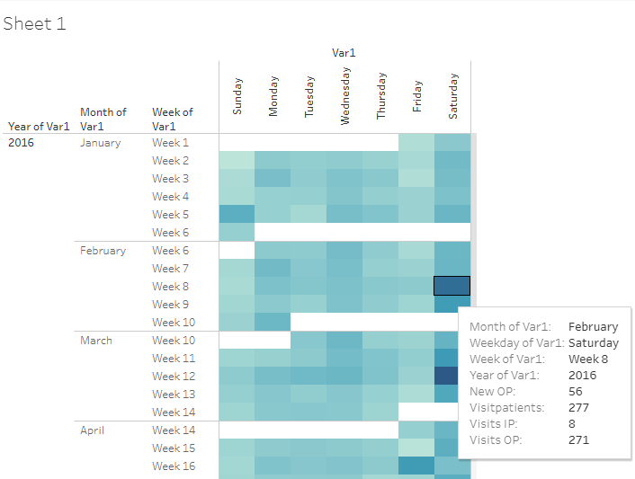

Reference files:
Tableau viz | 04_calendar_view
Tableau sheetname | Sheet 1

Patient visit view
There are 2 analysis views created for individual patient data. These show the longitudinal nature of data.

Columns displayed in the first view are follows: Patient ID (mr_no), gender, study day
- The Inpatient visits are displayed in blur color and Outpatient visits are displayed in Orange color.
- The tooltip contains information about the following data points not displayed on the page:
  - Studyday: Study day
  - Cdur: Total duration of hospital visits.
  - Description: Disease description variable accompanying ACD codes.
  - Medicine Name: Medicine provided at that visit.
  - Minday Metabolic: First day on which any metabolic disease has been reported by patient.
  - Minday RMSD: First day on which any RMSD disease has been reported by patient.

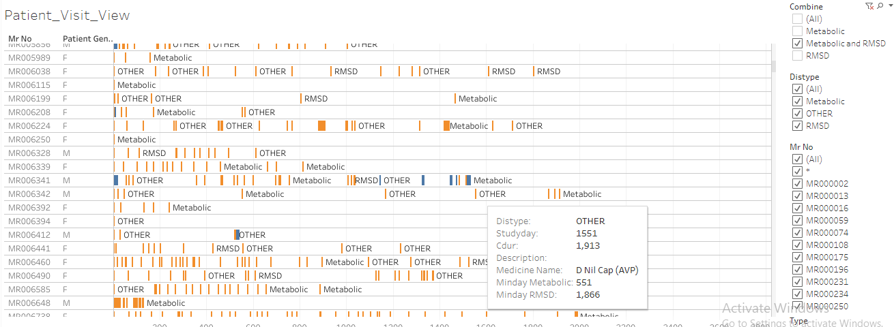

Reference files:
Tableau viz | 01SQL_Dis_Med_Ser
Tableau sheetname | Patient_Visit_View

Columns displayed in the second view are follows: Patient ID (mr_no), gender, base age, category, Code, description, study day
- The Diseases are displayed in blue colored bars and treatments prescribed are marked in orange colored bars.
- Bars are created as followed: Duration between minimum and maximum reported date for a disease as well as prescribed treatment is calculated, this duration is displayed on the visualization. This calculation needs improvements (algorithm is getting developed to derive individual episodes of diseases as well as individual episodes of treatment assignment)
- The tooltip contains information about the following data points not displayed on the page:
  - Daystt: Start of event in days (disease as well as treatment)
  - Disdur: Duration of event in days (disease as well as treatment)
  - Disstt: Start date of event
  - Diend: End date of event

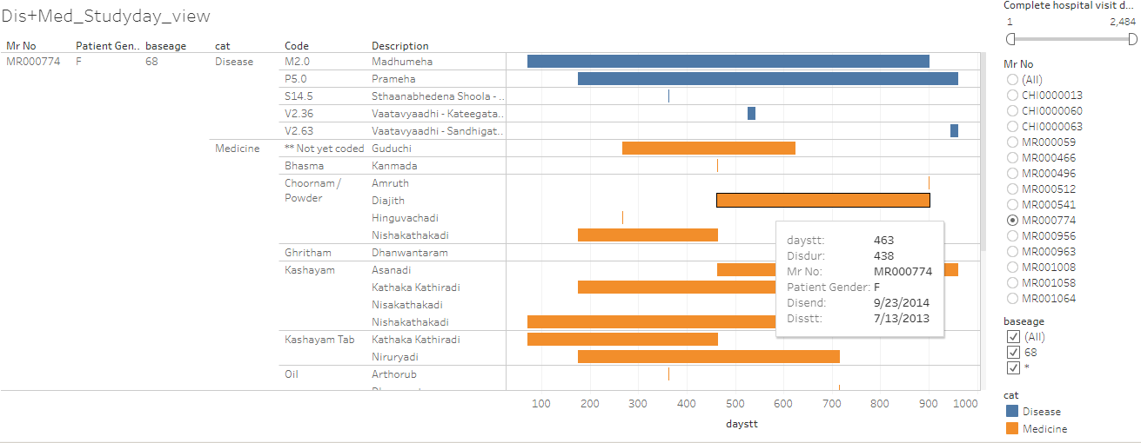

Reference files:
R program | 01_Primary_Gridhrasee.R, 01_Primary_madhumeha.R
Datafile | Primary_gridhrasee.csv, Primary_madhumeha.csv
Tableau viz | 01_Primary_Gridhrasee, 01_Primary_madhumeha
Tableau sheetname | Dis+Med_Studyday_view, Dis+Med_Studyday_view

Interpretation:
- White spaces between the bars represent days between 2 consecutive visits.
- Duration bars displayed one below the other provides an easy visualization of co-morbidities as well as co-prescription of medicines.
- For RMSD disease group, there are a lot more visits. The difference between consecutive visits is smaller than metabolic disease group.
- In the 2nd view, medicines are categorized into types: Bhasma, Ghritam, Kashayam, Oil, Choornam, etc. This classification helps in understanding treatment principles followed by the doctor while treating a disease.
- These 2 views should provide huge information at one glance to the treating doctor. These 2 views could be used as an additional helping aid while talking with patient F2F or over the phone.

Disease and treatment view, listing and summary
There are 3 analysis views created for individual patient data.
1st part of the analysis:
Patients are treated as they come to hospital. This visual provides a patient level view of number of diseases reported for the first time and then repeated, similarly treatment prescribed for the first time vs. a repeat of treatment.
- When a disease is reported very first time then that is considered “1st time disease reported”, any subsequent repetition is considered as “Repeat”.
- When a treatment is prescribed very first time then that is considered “1st time treatment prescribed”, any subsequent repetition is considered as “Repeat”.
- These 2 calculations are repeated through the data for each patient.

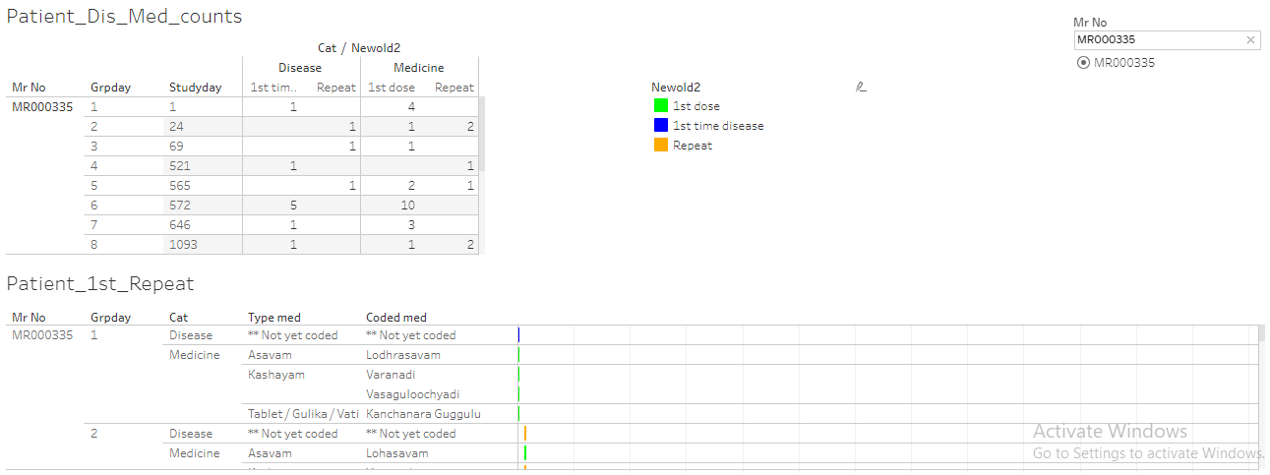

2nd part of the analysis:
This is a cumulative view for an individual patient. This provides a summary of what would have happened to a patient till a certain visit number. There are 2 tables created, first with absolute numbers and second with percentages.

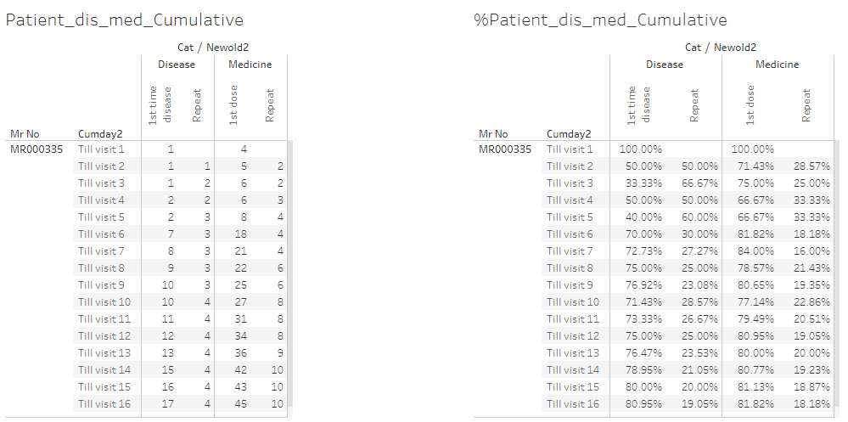

3rd part of analysis: This is another version of display of diseases and treatments for individual patients “non-overlapping or non-cumulative” version.
- Each line is a patient visit. 1st disease, Repeat disease, 1st treatment and Repeat treatment columns are displayed.
- Studyday column shows the visit day.

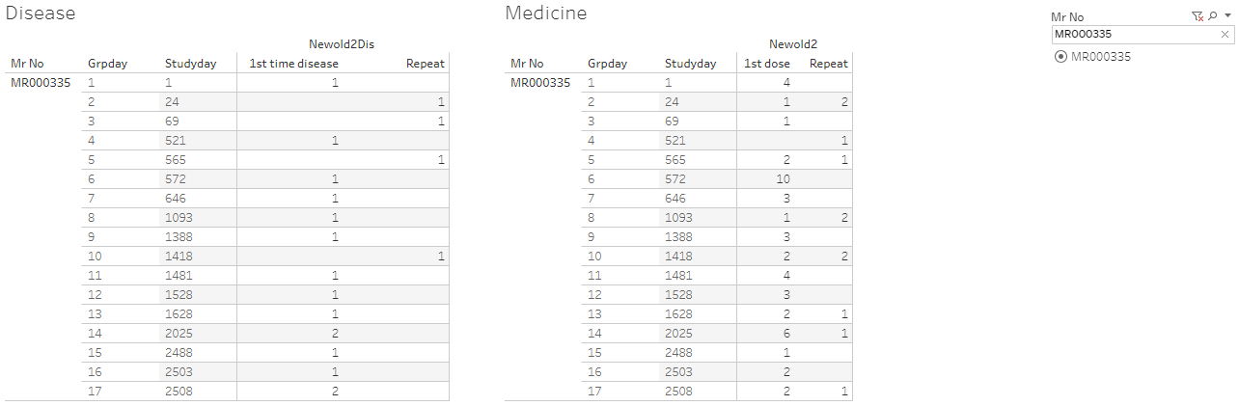

Reference files:
R program | 080_medicine_repeat_prop.R  080_medicine_repeat_prop_addnl_cal.R
Datafile | 080_medicine_repeat_prop.csv,  080_medicine_repeat_prop_cumulative.csv  080_medicine_dis_repeat_prop_cumulative.csv
Tableau viz | 080_medicine_dis_repeat_prop  080_medicine_dis_repeat_prop_cumulative
Tableau sheetname | Dashboard 1

Interpretation:
- When a new disease is reported, usually a new treatment or treatments are reported, if there is only a new treatment added then it could indicate, the earlier treatment may not have worked, or it explains the treatment regimen.
- If only new diseases are added and no new treatment is added then the same treatment could work for multiple diseases.
- The above example shows for patient MR000335,
  - There are 17 visits
  - There are 17 distinct diseases reported and 45 distinct treatments, services prescribed.
  - 4 out of 17 diseases are repeated and 10 out of 45 treatments have been repeated.
  - Based on the 3rd view, at visit 6 on day 572, there is only 1 new disease reported and 10 new treatments are added. At visit 14 on day 2025, there are 2 new diseases reported and 6 new treatments added.
- These visualizations allow the treating doctor insights into newer diseases getting reported as well as what newer treatments have been prescribed at what time points.

Disease view by seasonal variation
The following analysis provides frequency count of patients for each disease by month by gender.
- Unique combinations of patients, diseases by date and gender are created.
- Frequency counts are displayed.
- Counts of females are displayed in blur color and counts for males are displayed in orange color.
- This visual opens for each day, by clicking on “+” sign on the x-axis, showing the operational as well as scientific usefulness.

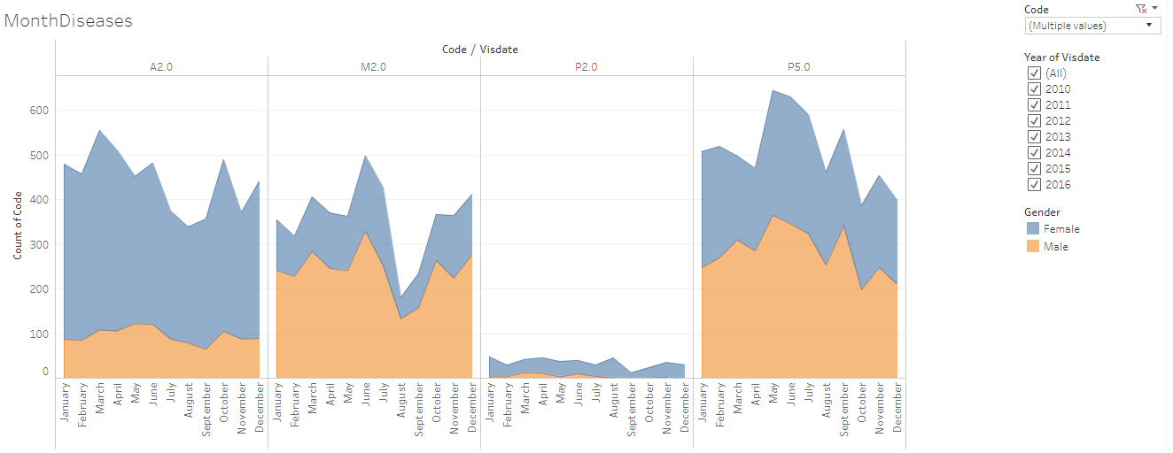
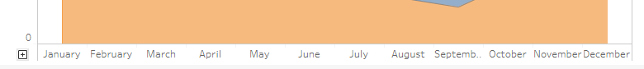
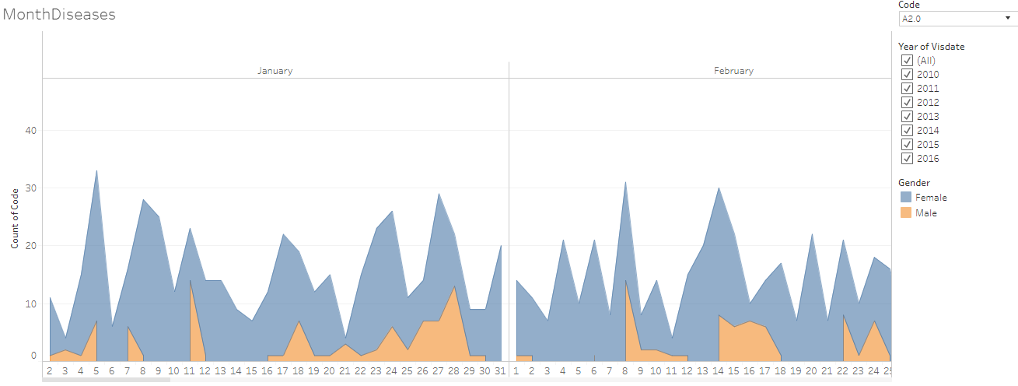

Interpretation:
- This provides information about 800+ diseases in very short space.
- Disease patterns are interesting due to following reasons:
  - Some diseases are reported more than a few other ones, it clearly gets shown easily.
  - Diseases vary seasonally.
  - Diseases are experienced differently by genders and it gets shown easily by looking at the distributions.
- This view is very useful for both operational excellence as well as clinical judgment.

Reference files:
Tableau viz | IndividualPatientCalendar
Tableau sheetname | MonthDiseases

Reference files for 2nd analysis carried out similar in nature:
Datafile | 01adsl_met_rmsd.rds
Tableau vizname | 01SQL_Dis_Med_Ser
Tableau sheetname | Slopegraph_disPatients, Slopegraph_disVisit

Rate of occurrence for diseases for metabolic and RMSD
After understanding the data and some operational side of it, let us understand the rate of occurrence for various diseases reported. The most frequently reported diseases have been sorted in ascending order.

- Metabolic disease group has 10 diseases and RMSD disease group has 100+ diseases.
- For Metabolic disease group the top 3 diseases are:
  - Prameha
  - Madhumeha
  - Sthaulya
- For RMSD disease group the top 5 diseases are:
  - Vaatavyaadhi – Sandhigata Vaata
  - Vaatavyaadhi
  - Vaatavyaadhi – Gridhrasee
  - Sthaanabhedana Shoola – Katee Shoola
  - Sthaanabhedana Graha – Katee Graha
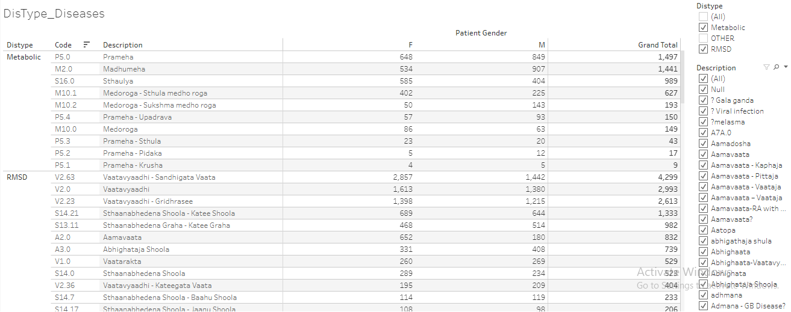

Reference files:
Datafile | 01adsl_met_rmsd.rds
Tableau vizname | 01SQL_Dis_Med_Ser
Tableau sheetname | DisType_Diseases

The analysis was carried out for disease group by gender and Indian seasons.
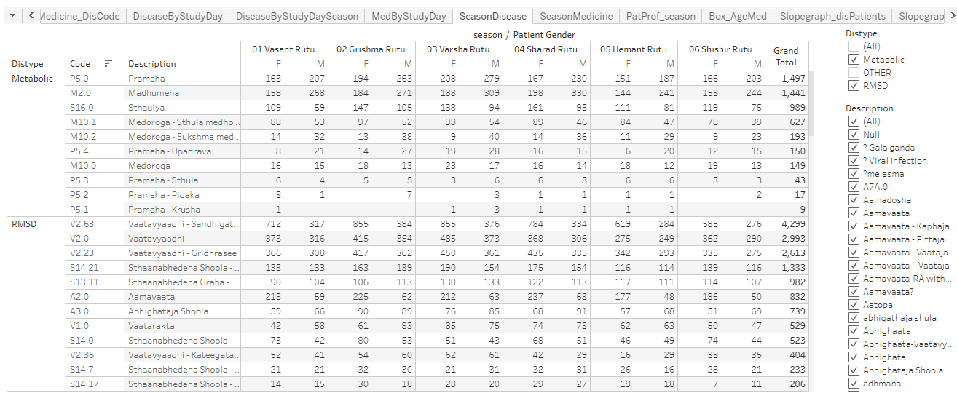

Reference files:
Datafile | 01adsl_met_rmsd.rds
Tableau vizname | 01SQL_Dis_Med_Ser
Tableau sheetname | SeasonDisease

There are many analysis created using to get additional insights into the data.

Interpretation:
- Prameha and Madhumeha are reported more by males than females.
- There are more female patients with disease condition Sthaulya.
- In general, RMSD diseases are reported by more number of females than males.
- For RMSD disease group, 51 out of 100+ disease are reported by <= 10 patients.

Medicine prescription by day
There are numerous medicines prescribed. These medicines are classified into following broad categories:
- Abhyanga
- Aristham
- Arka
- Asavam
- Avagha
- Bhasma / Bhasma Cap / Bhasma Tab
- Dhara
- Ghritam and variations of Ghritam
- Kashayam and variations
- Kshar
- Lehyam
- Oil
- Pichu
- Rasayanam
Etc.
Source variable for treatment will be classified into the following categories. This should allow recreation of treatment protocol as per ayurvedic principles.

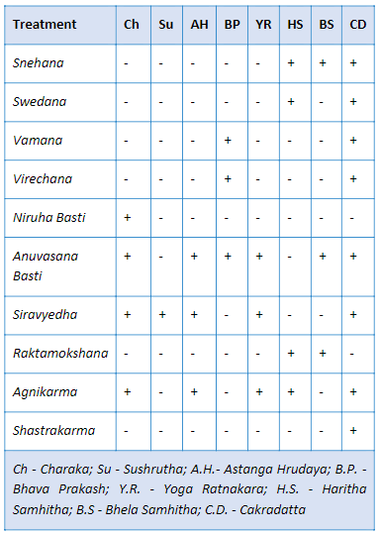

Interpretation:
- Arka, Avagha are prescribed to very few patients.
- Bloddletting has been advised to a few patients.
- Kashayam has been

Reference files:
Datafile | 01adsl_met_rmsd.rds
Tableau vizname | 01SQL_Dis_Med_Ser
Tableau sheetname | MedicineByDay

Co-morbidity analysis
Patients report multiple diseases through their visits to the hospital. There are known as well as unknown disease combinations present due to biological linkages. 3 different analysis provide insights into co-morbidities observed through the existing data.

Algorithm for 1st analysis:
- Create unique combinations of Patient ID, gender and reported disease at any given time point.
- Subsequently create a dataset having combination of 2 diseases for individual patient. E.g. if a patient has reported 5 unique diseases then all the combinations of these 5 diseases will be created.
- The resulting data will have the following structure: Patient ID, Primary disease, Secondary disease, gender.
- Frequency count of distinct patients will be calculated for each Primary disease, Secondary disease combination and gender.
- Using this data following analysis is carried out:
  - Summary statistics of age group for each secondary disease by gender.
  - Boxplot of age group for each secondary disease by gender.
  - Bubble plot for each disease, bubble size is determined by the count of unique patient ID.
  - For a primary disease how many other unique diseases are reported is calculated by gender.
  - Tooltip on the bubble plot provides information about count of distinct number of patients, and summary statistics for age group.
- The dashboard is controlled by a “PrimaryCode” or a reference disease. The corresponding data is displayed on the page.
  - The bubble plot displays the number of distinct patients having the primary disease.
  - Other bubbles display the diseases reported by this subset of patients at any point in time (these could be clinically related or unrelated, could have occurred before or after the occurrence of reference disease).
  - The tooltip shows min, median and max age, distinct counts of patients.
  - A small table on the left side shows number of other diseases experienced.
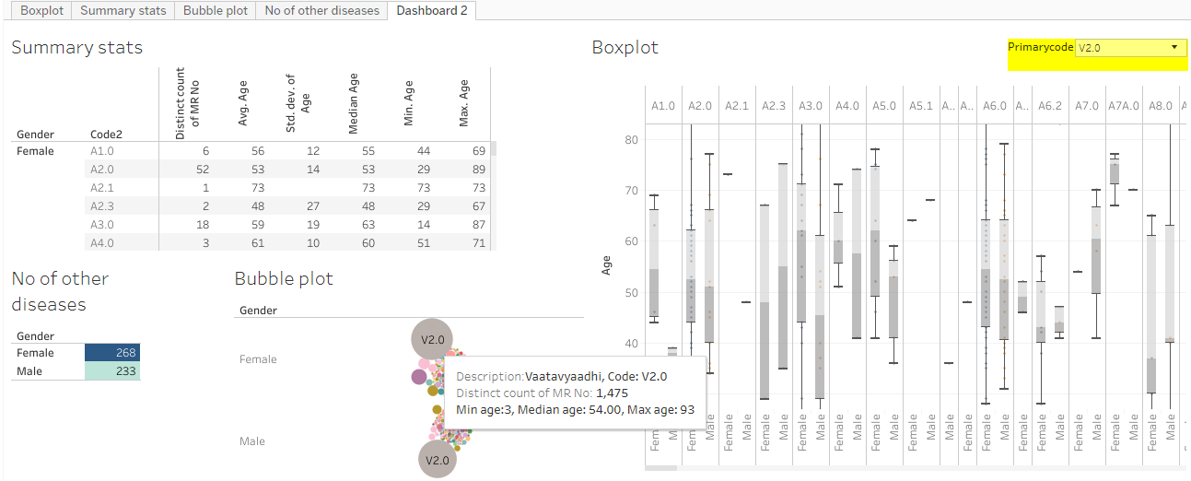

Algorithm for 2nd view: all the steps are same as 1st analysis + addition of monthly variation.

Same calculations for 1st algorithm are followed to create co-morbidities, in addition time factor of month has been added to get insights into seasonal variation.

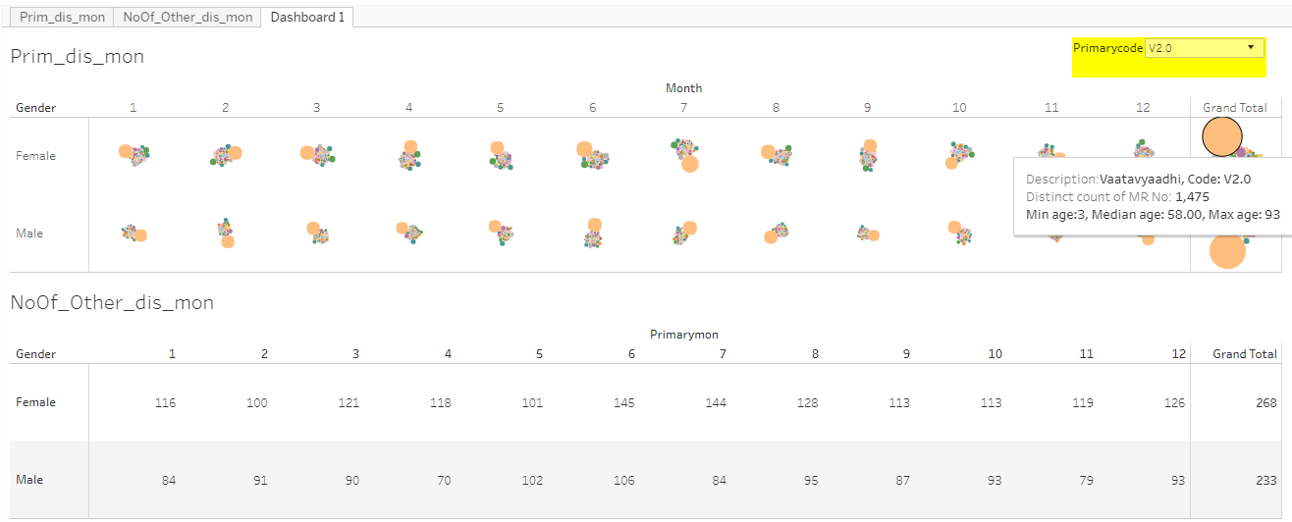

Algorithm for 3rd analysis: steps are similar to the 1st analysis + chronology of diseases is maintained. How is the trajectory of the diseases unfolds is depicted here. The visual display is created in a form of collapsible tree. A brief flow chart of the analysis is as follows:
- Diseases experienced by each patient are sorted by date and only 1st instance of a disease is retained.
- For each disease trajectory the frequency counts are created and are displayed as a collapsible tree.
- This tree shows progression of diseases as experienced by patients in the database.
- This tree shows approximately 12,500 lines of data in very short space.
- Some diseases are experienced more by males or by females. Some diseases are only reported by one of the genders.
- Some diseases have many more branches than a few others.
- The tree has filled blue dots which open up additional branches, white filled blue dots are the end of the branch, (N=xx) at each of the branches display number of patients reporting that disease trajectory.
- Some of the disease trajectories have very few numbers of patients. Some of the trajectories may be clinically meaningful and some may not be meaningful.

Technical details behind the flowchart:
- Disease trajectories are created using R programming. Final output stored in Json file.
- Json file is used the input to the D3js Java programming.
- Index.html file is hosted on the Github page to create the interactive page https://coursephd.github.io

Initial view of the tree
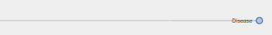
Example of Vaatavyadhi -- Gridhrasee

After clicking on F, the tree opens up
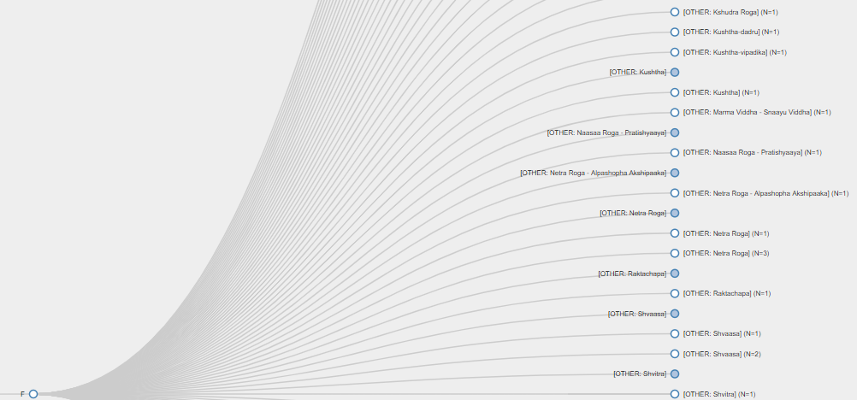

An example of a disease experienced only by one gender
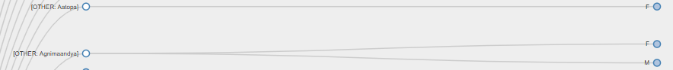

Interpretation:
- This display provides a comprehensive view of the disease clusters. Comorbidities are easily identified, some of them are clinically relevant, and some of them are not.
- Bubble size provides comparative view of number of patients reporting a specific disease. The age group distribution for each gender is available. Some diseases are reported more by males or by females, easy to spot on the graph.
- Box named “Number of other diseases” provides a contextual display about number of co-morbidities. Some diseases have higher number of co-morbidities, some have lower number. Variations are seen amongst gender as well.
- This analysis does not take into account the before or after nature of time points, so this does not provide insights into the causal relationships between diseases.
- 2nd analysis provides views on the seasonal variations of diseases as well as seasonal co-morbidities.

Reference files:
R program | diagnosis_primary.R, diagnosis_primary_month.R
Tableau viz | Primary_disease_and_all_other_diseases , PrimDis_otherDis_ByMonth
Tableau sheetname | Dashboard 2, Dashboard 1
Collapsible tree | https://coursephd.github.io

Treatment and disease combinations
The Patient Report form or Case Report form captures diseases reported on a particular visit along with treatments and services prescribed to a patient. Due to the nature of the CRF page, multiple diseases and treatments are captured on the same visit. This creates many to many relationships and dilutes one to one relation. Even though this challenge exists, the data at a summary level provides good view on treatment and disease relationship.

Medicine and disease group rate of occurrences are calculated as well as medicine and individual disease rate of occurrences are calculated.

E.g. Use Balaristham as a case:
- Balaristham is prescribed to the following number of patients.
- The source variable captures the quantity + unit + company name are presented in the same variable, which does not allow for numerically correct calculations.
- Coded variable is created to get around this challenge.
- The medicine is prescribed for RMSD group. It is not used so much for Metabolic group.

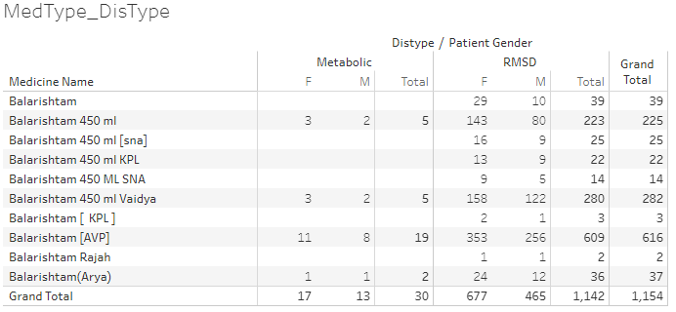

2nd example of bhasma:
- Approximately 287 patients out of 17406, 1.5% of patients are prescribed bhasmas for various diseases.
- Traditionally bhasmas of any kind are prescribed in very limited quantity and same is reflected in observed data.
- Naming convention and spelling correctness need to be considered while capturing data in future.

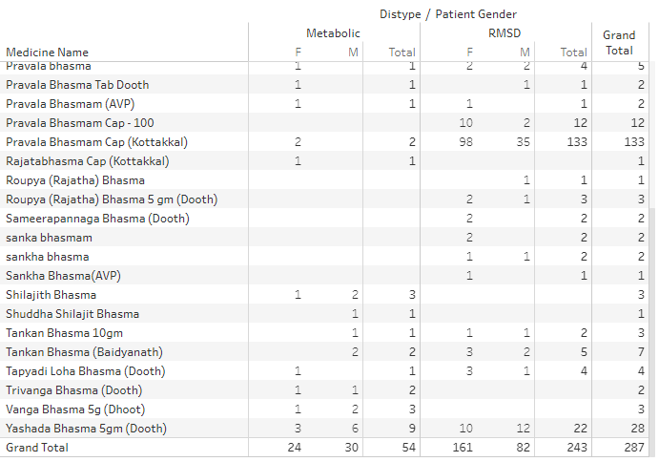

Reference files:
Datafile | 01adsl_met_rmsd.rds
Tableau vizname | 01SQL_Dis_Med_Ser
Tableau sheetname | MedType_DisType  Medicine_DisCode  MedByStudyDay  SeasonMedicine  Box_AgeMed

ICD coding of diseases
National morbidity codes by CCRAS under guidance of Ministry of AYUSH

ISO coding for background work history

Dataset with each disease considered as a reference disease having day 1
This data is generated from every day medical practice at the hospital. Hence the diseases are reported almost at random. The following analysis uses 1st occurrence of any disease as day 1 at an individual patient basis. Using this as reference day “before period” and “after period” is derived. “Before period” provides significant amount of “baseline data”, “after period” provides specific insights into what would happen after the reference disease.

Algorithm to create the underlying data for analysis:
- Each of the 106 diseases (10 Metabolic and 96 RMSD) is considered as a reference disease.
- Day 1 is calculated as the reference day 1 for individual patient for each disease.
- Other diseases for the same patient are positioned either before or after compared to this reference disease.
- Duration w.r.to this reference day is calculated before and after day 1. This calculation provides the background view as well as future view.
- This referencing allows for more informative background disease as well as background medicine information. The duration is split into the following time points:

Before | After
Day 1 as reference
Before 1 month | Within 1 month
Before 2 months | Within 2 months
Before 3 to 6 months | Within 3 to 6 months
Before 7 to 12 months | Within 7 to 12 months
Before 2nd year | Within 2nd year
Before 3rd year | Within 3rd year
Before 4th year | Within 4th year
Before 5 year | Within 5 year

Details about the analysis file:
- 1 sheet for each reference disease is created.
- Frequency count of diseases and prescribed medicines is displayed.
- “Before period” counts are displayed in red colour and “After period” counts are displayed in Green colour. This analysis provides good insights into the causal relationships.

E.g. use Prameha as an example:
- Prameha has been reported by 1497 patients. Out of these 383 patients visit hospital within 1st month, 231, 269, 167, 128, etc are in the following time points.
- Other lines in the table provide details about diseases reported by these 1497 patients.
- Bottom section of the table provides information about the treatment details for these patients.

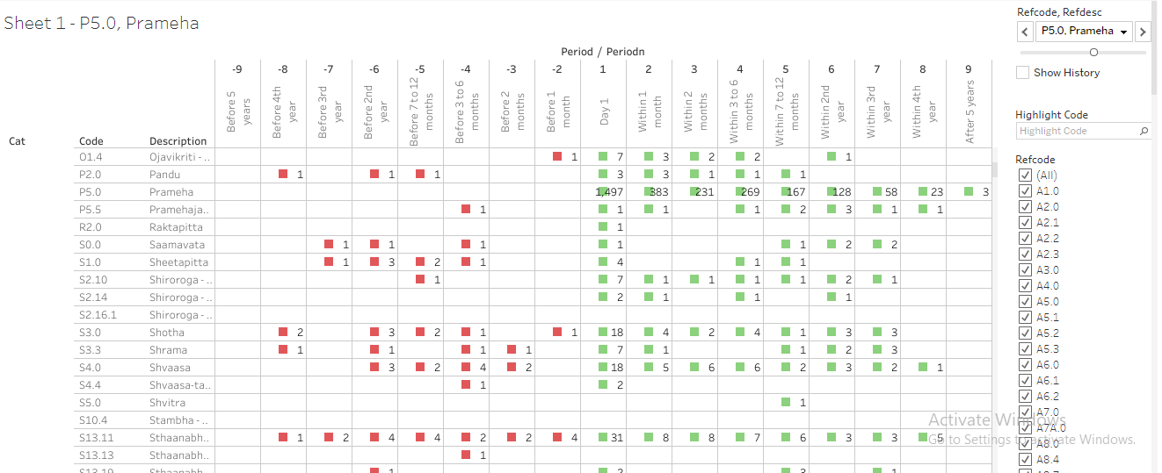

Another example of Vaatavyadhi – Gridhrasee, 4299 patients have reported at least once.

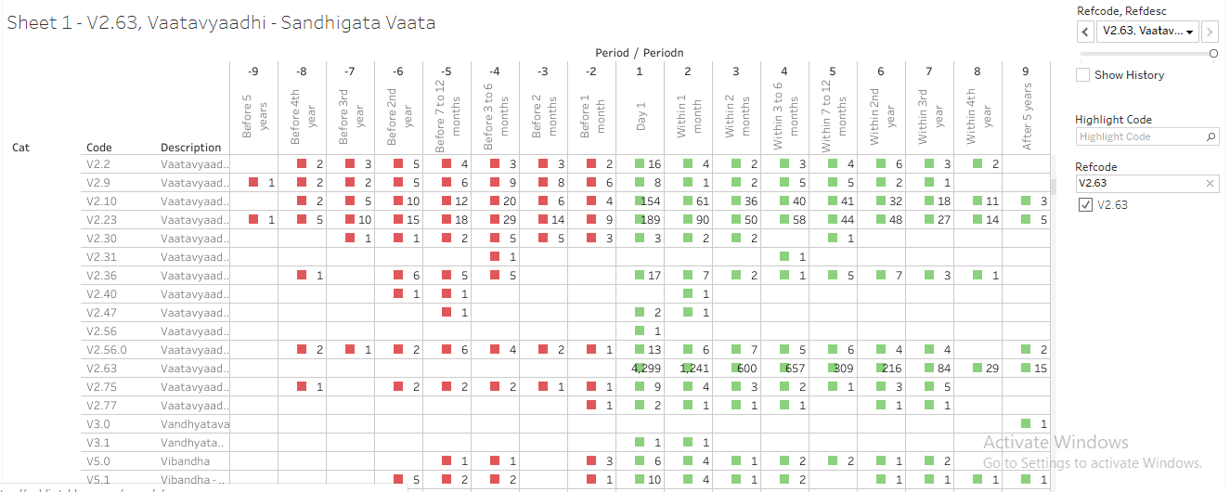

Reference files:
R program | 085_dis_1st_time_refCal_NodesEdges.R
Datafile | 085_dis_1st_time_refCal_NodesEdges.csv  085_dis_1st_time_refCal_NodesEdges.rds
Tableau vizname | 085_dis_1st_time_refCal_NodesEdges
Tableau sheetname | Sheet 1- <Disease code>, <Disease name>

Circular disease and treatment view
This is 2nd analysis carried out on the data prepared earlier.

Details about the display:
- For each reference disease 1 page is created. Each page is controlled by a combination of “Reference disease + disease”, “Reference disease + medicine”
Reference disease window: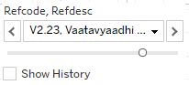,
Reference disease or medicine window: 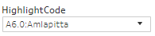

- Tables displayed in the top part of the display:
  - There are 9 columns created for each time point.
  - 2 columns are displayed in each time point to display “count of distinct number of diseases” and “count of distinct number of medicines”.
Count of distinct number of diseases: 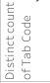
Count of distinct number of medicines: 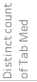
  - There are 3 rows for “Before period”, “Day 1” and “After period” with 2 lines in each period.
  - Day 1 cell shows the start day of reference disease “V2.23: Vaatavyadhi – Gridhrasee”,
    - This example shows 137 total number of distinct diseases reported and 664 total number of distinct medicines prescribed on day 1 for this combination of reference disease “V2.23: Vaatavyadhi – Gridhrasee” and disease “A6.0: Amlapitta”.
    - The first line in the Day 1 cell shows, 1 disease – which is “A6.0: Amlapitta” and 81 distinct medicines prescribed. These 81 different treatments could have been prescribed for “A6.0: Amlapitta”.
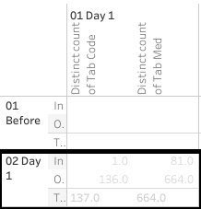
  - Cells in the “Before period” line provide the following information:
    - This example shows 1 month before “V2.23: Vaatavyadhi – Gridhrasee”, there were 61 distinct diseases and 298 distinct medicines reported.
    - The first line in the cell shows, 1 disease – which is “A6.0: Amlapitta” and 11 distinct medicines prescribed. These 11 different treatments could have been prescribed for “A6.0: Amlapitta”.
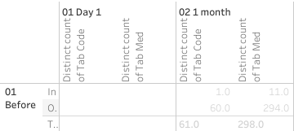
  - Cells in the “After period” line provide the following information:
    - This example shows 1 month before “V2.23: Vaatavyadhi – Gridhrasee”, there were 96 distinct diseases and 633 distinct medicines reported.
    - The first line in the cell shows, 1 disease – which is “A6.0: Amlapitta” and 49 distinct medicines prescribed. These 49 different treatments could have been prescribed for “A6.0: Amlapitta”.
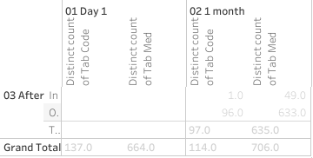
- The bottom section follows the same structure as the top section. The following table provides distinct number of diseases reported and distinct number of medicines prescribed for this particular combination. There are 308 diseases and 1357 medicines reported for this combination of reference disease “V2.23: Vaatavyadhi – Gridhrasee” and disease “A6.0: Amlapitta”.
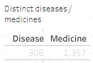
- Explanation about the circular view:
  - The starting point marks the position of the other disease in this case, “A6.0: Amlapitta”,
  - The green colored spokes going from point of origin are different treatments prescribed.
  - These are showing 664 distinct medicines prescribed on day 1.

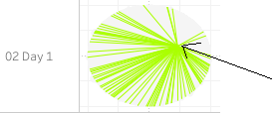
  - Hovering tooltip provides details about the disease, treatment name and count of number of patients: 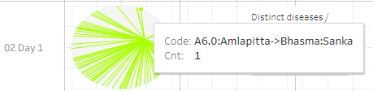

- The inner circle displays the diseases.
- The outer circle displays the treatments.

Circular view of disease and medicine view allows the following comparisons:
- Relationship between diseases and treatments across different time points.
- If a disease is experienced in different time windows then would the treatment options look different or would they look similar.
- Occurrence of diseases and proximity -- do the diseases precede and / or succeed each other, etc.

E.g. Amavaata, what all diseases were experienced and treatments given before the 1st occurrence of disease and after the 1st occurrence of disease. How far or how close were these events are given in terms of within 1 month, within 2 months, within 3 to 6 months, 1 year, 2year etc. on both sides.

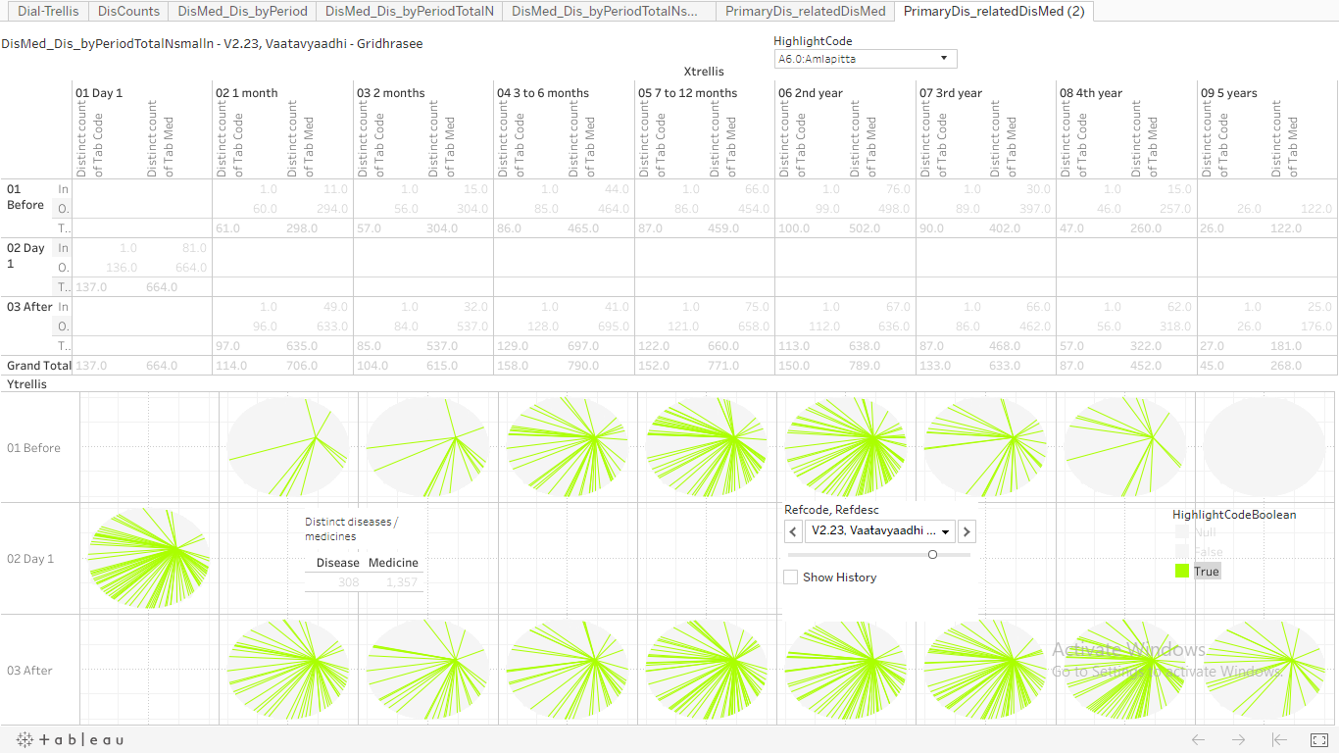

Example view of the combination of a treatment “Dhanwanaristham” and reference disease “V2.23: Vaatavyadhi – Gridhrasee”. Very few Green colored lines show that this treatment may not be a heavily used treatment against this specific disease condition.

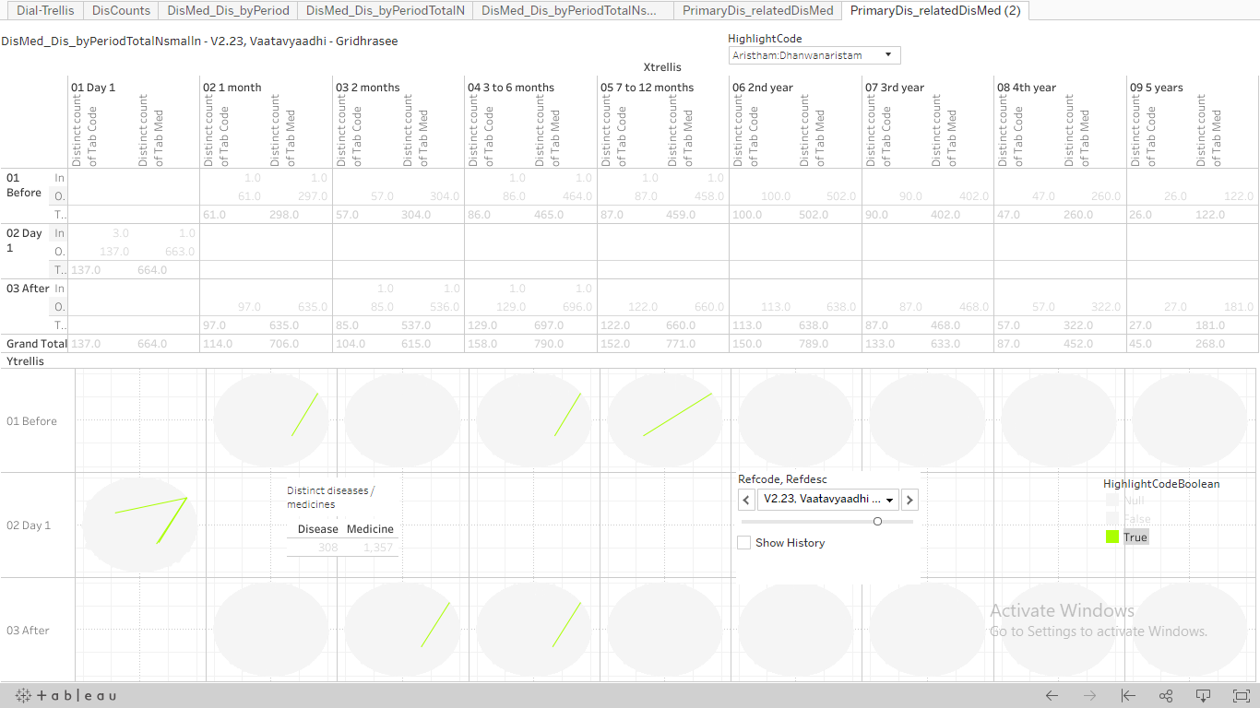

Before and after disease and treatment java view
This is 3rd analysis carried out on the data prepared earlier.
- What is CKD and how does it relate to the V16.0 Vrikka Roga in ayurveda?
There's no cure for chronic kidney disease (CKD), but treatment can help relieve the symptoms and stop it getting worse. ... The main treatments are: lifestyle changes – to ensure you remain as healthy as possible medication – to control associated problems, such as high blood pressure and high cholesterol.
Vrikka Roga analysis
The hospital database contains approximately 320 patients who have reported Vrikka Roga at least once between years 2011 and 2017. The ACD classification V16.0 identifies Vrikka Roga. It is equivalent to the Chronic Kidney Disease reported in the western medicine.
Serum creatinine level > 1.8 mg/dL
- What is the available data in public forums?
The approximate prevalence of CKD is 800 per million population (pmp), and the incidence of end-stage renal disease (ESRD) is 150–200 pmp.(0.1% rate for both these stages put together). Community studies estimate the prevalence between 0.16% and 0.79%, the hospital database proportion of patient is 318 / 51000 ~ 0.62%, it is in the range reported by the authors. 70% of male patients are observed.
How fast or slow is the progression from CKD to ESRD to resulting in a renal transplant?
https://www.karger.com/Article/FullText/199460
http://www.apiindia.org/medicine_update_2013/chap130.pdf

- Who is likely to get it, at what age, which gender?

The database has 79 female and 239 male patients reporting the disease, 46 females out of 79 female patients have reported other diseases. 139 males out of 239 male patients have reported other diseases. 25% females and 75% male patients contribute to the total number of patients. This proportion is similar to other big databases.

56.8 (16.9) years is the average (SD) age reported by females. 61.8 (17.0) years is the average (SD) report by males. The minimum reported age is 2 years for males and females, whereas 85 and 89 are the maximum reported ages for females and males respectively.

127 patients reported only single disease and 185 patients have reported multiple diseases. Approximately 40% of patients report only Vrikka Roga. 240 (~75%) patients report Vrikka Roga on day 1 of coming to the hospital. A lot of patients would come to Ayurvedic treatment option after trying out all other options. Or a lot of patients would be coming to take second opinion and never come back for any additional visits.

93 (29%) patients reporting only single disease visit hospital only once. 38 (12%) patients reporting multiple diseases visit hospital only once.

The following table outlines the distribution of patients continuing on for specific periods of time:

Day 1 | 310 (100%)
Within 1 month | 90 (29%)
Within 2 months | 60 (19%)
Within 3 to 6 months | 64 (20%)
Within 7 to 12 months | 33 (10%)
Within 2nd year | 19 (6%)
Within 3rd year | 7 (2%)
Within 4th year | 1
Within 5th year | 1

There is a steep decline in number of patients after 1st day. By the 2nd year, there are only 6% patients taking any medicine, 2% continue for 3rd year and more. Only 1 patient has continued for more than 4 years.

Approximately 90 (28%) patients have reported diabetes and heart disease. Approximately 35 (10%) patients have reported renal diseases.

Analysis of lab parameter Creatinine (mg/dL):

127 (40%) patients have reported creatinine value and summary statistics is as follows:

Unique patients | Mean | Median | SD | Min | Max
127 (40%) | 5.01 | 4.5 | 3.20 | 0.7 | 21.0

Analysis for Male and female patients: mean (median) values for males are considerably higher than for females.

Unique patients | Mean | Median | SD | Min | Max
Male: 99 (31%) | 5.48 | 5.18 | 3.42 | 0.7 | 21.0
Female: 28 (9%) | 3.77 | 3.30 | 2.06 | 0.9 | 9.6

Analysis for patients with single and multiple diseases: patients reporting only Vrikka roga have mean (median) values considerably higher than patients who have reported multiple diseases.

Unique patients | Mean | Median | SD | Min | Max
Multiple: 78 (25%) | 4.71 | 3.76 | 3.10 | 0.7 | 14.5
Single: 49 (15%) | 5.82 | 6.00 | 3.32 | 0.7 | 21.0

Analysis by time point: for both types of patients, the mean and median values at post-baseline time point are lower than that of the pre-baseline time point, showing some benefit.

 | Time point | n | Mean | Median | SD | Min | Max
Multiple disease | 01-Pre-baseline | 44 | 4.86 | 3.83 | 3.23 | 1.5 | 13.87
Multiple diseases | 02-Post-baseline | 50 | 4.59 | 3.70 | 2.99 | 0.7 | 14.50
Single disease | 01-Pre-baseline | 37 | 5.89 | 6.00 | 2.89 | 0.9 | 14.60
Single disease | 02-Post-baseline | 18 | 5.68 | 5.95 | 3.66 | 0.7 | 21.00

Analysis by time point and gender: males having only Vrikka Roga as a single disease reported have mean value more than 5 mg/dL for both the time points and may not have been benefited in reducing the creatinine value. Males having reported multiple diseases have pre-baseline value around 5 mg/dL and report small reduction at post-baseline time point.

Female patients with only Vrikka Roga show reduction in creatinine values from pre-baseline to post-baseline, but the number of patients is very low. Females reporting multiple diseases show reversal in creatinine values, they worsen at post-baseline time point.

 | Time point |  | n | Mean | Median | SD | Min | Max
Multiple diseases | 01-Pre-baseline | F | 9 | 2.85 | 2.05 | 1.61 | 1.5 | 6.20
Multiple diseases | 02-Post-baseline | F | 13 | 4.03 | 3.65 | 1.91 | 0.9 | 7.70
Multiple diseases | 01-Pre-baseline | M | 35 | 5.60 | 4.83 | 3.37 | 1.5 | 13.87
Multiple diseases | 02-Post-baseline | M | 37 | 4.83 | 3.72 | 3.33 | 0.7 | 14.50
Single disease | 01-Pre-baseline | F | 6 | 5.90 | 5.51 | 2.18 | 3.4 | 9.60
Single disease | 02-Post-baseline | F | 4 | 3.79 | 2.60 | 2.67 | 1.3 | 7.30
Single disease | 01-Pre-baseline | M | 31 | 5.88 | 6.00 | 3.04 | 0.9 | 14.60
Single disease | 02-Post-baseline | M | 14 | 6.31 | 6.05 | 3.78 | 0.7 | 21.00

Analysis for patients at time points of baseline and post baseline. Baseline is defined as any value on or before day 1 of Vrikka Roga, post baseline is defined as any value on or after day 1 of Vrikka Roga.

Unique patients | Mean | Median | SD | Min | Max
Pre-baseline: 81 (26%) | 5.28 | 5.00 | 3.11 | 0.9 | 14.6
Post-baseline: 68 (14%) | 4.82 | 4.80 | 3.16 | 0.7 | 21.0

The mean and median values for post-baseline are lesser than that of the baseline values. This shows favorable treatment effect on kidney function.

Gender wise view of the pre-baseline and post-baseline values of creatinine:

Male: The mean and median values for post-baseline are lesser than that of the baseline values.
Unique patients | Mean | Median | SD | Min | Max
Pre-baseline: 66 (%) | 5.72 | 5.40 | 3.20 | 0.9 | 14.6
Post-baseline: 51 (%) | 5.16 | 4.90 | 3.47 | 0.7 | 21.0

Female: The mean and median values for post-baseline are bigger than that of the baseline values.
Unique patients | Mean | Median | SD | Min | Max
Pre-baseline: 15 (%) | 3.76 | 3.15 | 2.26 | 1.5 | 9.6
Post-baseline: 17 (%) | 3.98 | 3.48 | 2.04 | 0.9 | 7.7

Overall pre-baseline values for males are higher than that of pre-baseline female values. Females may not have been benefitted in reducing the creatinine values.

Following box plots show the data in graphical format:
- The first box plots show the data by gender and comparison of baseline and post baseline data. There are a few patients with lab data but no dates associated with them.
- The values of 2 mg/dL and 5 mg/dL are marked as red colored dashed lines to show abnormal value upper limit and kidney failure levels. There are a lot of values more than 10 mg/dL for males at both time points. Females have not reported values of more than 10 mg/dL
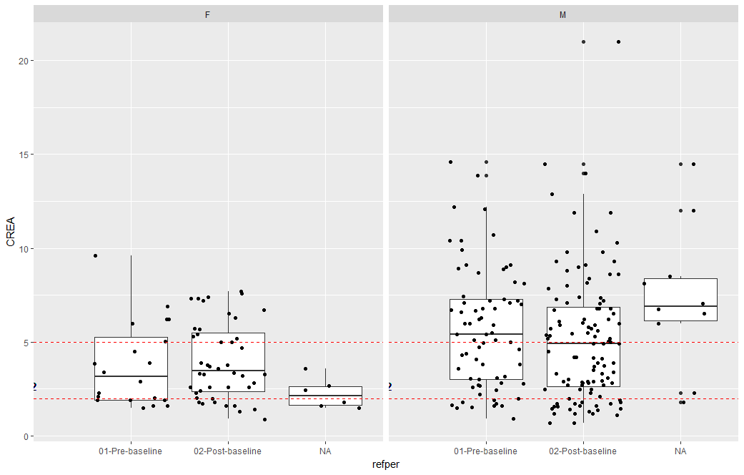

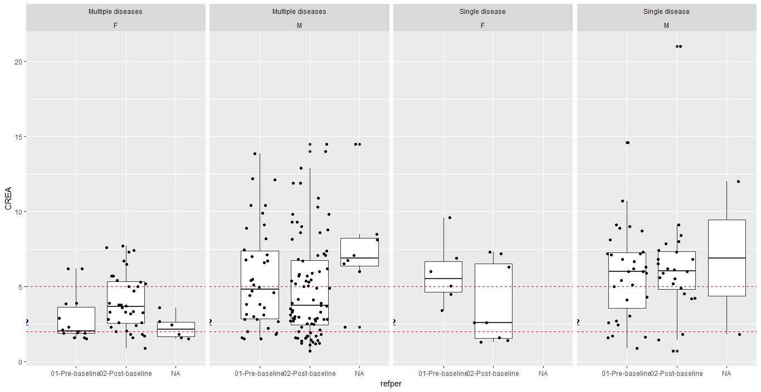

Analysis of lab parameter Potassium (mg/dL):

127 (40%) patients have reported creatinine value and summary statistics is as follows:

Unique patients | Mean | Median | SD | Min | Max
43 (13%) | 5.57 | 5.4 | 1.13 | 3.7 | 12.1

Analysis of lab parameter Hemoglobin (mg/dL):

127 (40%) patients have reported creatinine value and summary statistics is as follows:

Unique patients | Mean | Median | SD | Min | Max
76 (24%) | 9.73 | 9.8 | 2.07 | 4 | 14.5

- Is it a chronic disease or an acute disease, even if “chronic” is present in the name?
- Is it possible to cure it fully, or would it have frequent recurrence?
- What are the co-morbidities experienced, either along with disease or before as well as after?
- Is the disease experiences seasonal variations?
- What are the grades for CKD?
- Is it simple to diagnose CKD or is there a possibility of misdiagnosis?

